Introduction

Islamic Social Services Association (ISSA) hosted Increase Your Social Media Literacy: Build Resistance to Exploitation and Self-Harm on Saturday, July 25, 2026, at Hilton Suites, 1800 Wellington Avenue in Winnipeg. The free workshop was designed for youth ages 16 and older and was designed to help young people better understand the digital environments they use every day. Rather than presenting social media use simply as a matter of personal responsibility or telling young people to spend less time online, the workshop examined the systems and behaviours that influence how people interact with technology. Participants were introduced to the ways social media platforms use algorithms, engagement signals, notifications, infinite scrolling, streaks, and personalized recommendations to maintain attention.
The workshop also addressed the risks that can arise within these digital environments. Participants learned about online exploitation, grooming, manipulation, harmful online behaviour, synthetic media, AI-generated content, and the difficulty of determining whether digital content is authentic. The program connected these issues to practical questions about how young people can protect themselves, recognize warning signs, evaluate information, and develop healthier digital habits.
A central part of the workshop was the recognition that social media literacy involves more than knowing how to use an app. It also involves understanding how platforms influence what users see, why certain content is recommended, how content becomes widely distributed, how people can be manipulated online, and how technology can be used to create highly convincing synthetic content.
The workshop was structured to move from understanding personal digital behaviour to understanding the broader systems behind social media, followed by practical exercises focused on exploitation, manipulation, synthetic media, and personal digital wellness. Participants were given opportunities to discuss scenarios, examine digital content, reflect on their own habits, and consider strategies for creating healthier and safer online environments.
The event was also designed with accessibility in mind. The workshop was free, registration was required, lunch was provided, and bus tickets were made available to participants. These supports helped reduce some of the practical barriers that can prevent youth from attending a full-day community workshop.

Goals of the Workshop

The first goal was to increase participants' understanding of how social media platforms influence attention and behaviour. The workshop introduced concepts such as dopamine and reward-seeking, infinite scrolling, streaks, push notifications, personalized recommendations, and engagement-based algorithms. Participants were encouraged to think about their own screen use not simply as an issue of willpower, but as something influenced by intentional technological design.
The second goal was to help participants recognize online exploitation and manipulation. Through the presentation by Cpl. Emmie Clements of the Manitoba Integrated Child Exploitation Unit, participants were introduced to online grooming, manipulative behaviours, and warning signs associated with online exploitation. The workshop emphasized that manipulation can follow recognizable patterns and that recognizing those patterns can help young people respond more safely.
The third goal was to develop participants' ability to critically evaluate AI-generated and synthetic media. Through Jamal Tajdin and Ghislain Druwé's session, participants examined how synthetic content can be created and distributed and how algorithms can amplify both useful and misleading information. The Morgan Freeman AI demonstration provided a concrete example of how convincing synthetic media can appear and how easily people may be misled when they do not question the authenticity of digital content.
The fourth goal was to help participants develop practical strategies for digital wellness and resistance. Participants were introduced to strategies such as delaying the impulse to open an app, creating friction around distracting applications, removing unnecessary notifications, batching social media use, setting boundaries around screen time, and intentionally curating their feeds.
The fifth goal was to create an interactive space where participants could apply what they were learning. The program included a Conversation Café, small-group scenario analysis, breakout activities related to synthetic media, and a personal digital wellness assessment. These activities were intended to move participants beyond simply receiving information and toward discussing, questioning, and applying the concepts presented.

Attachments
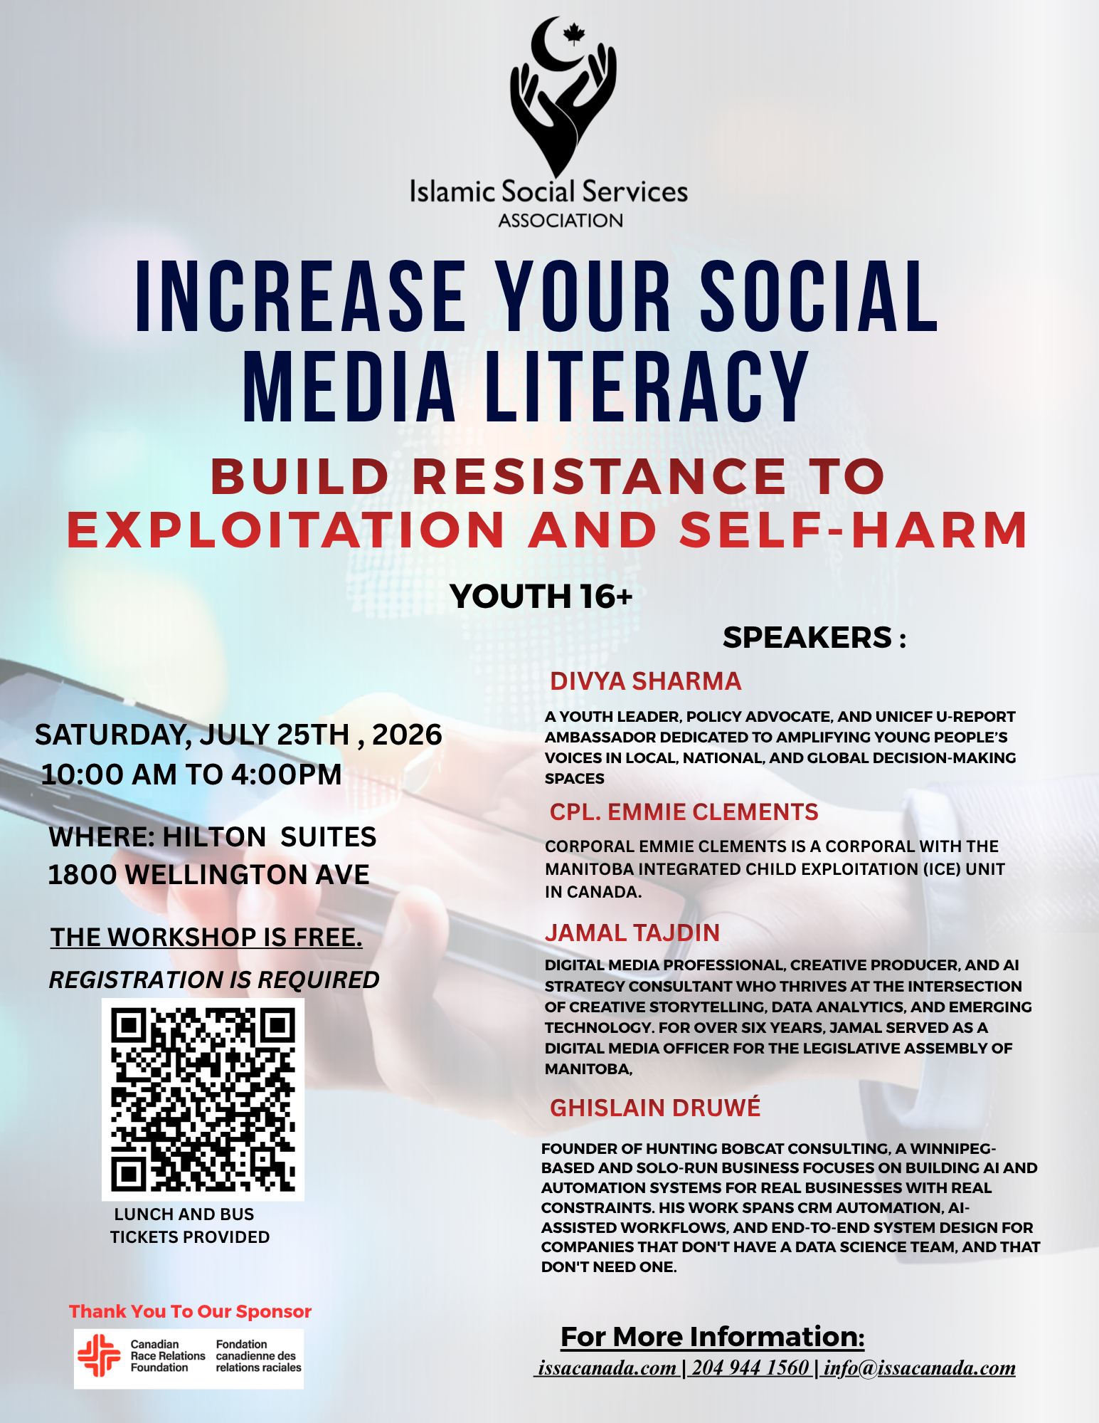

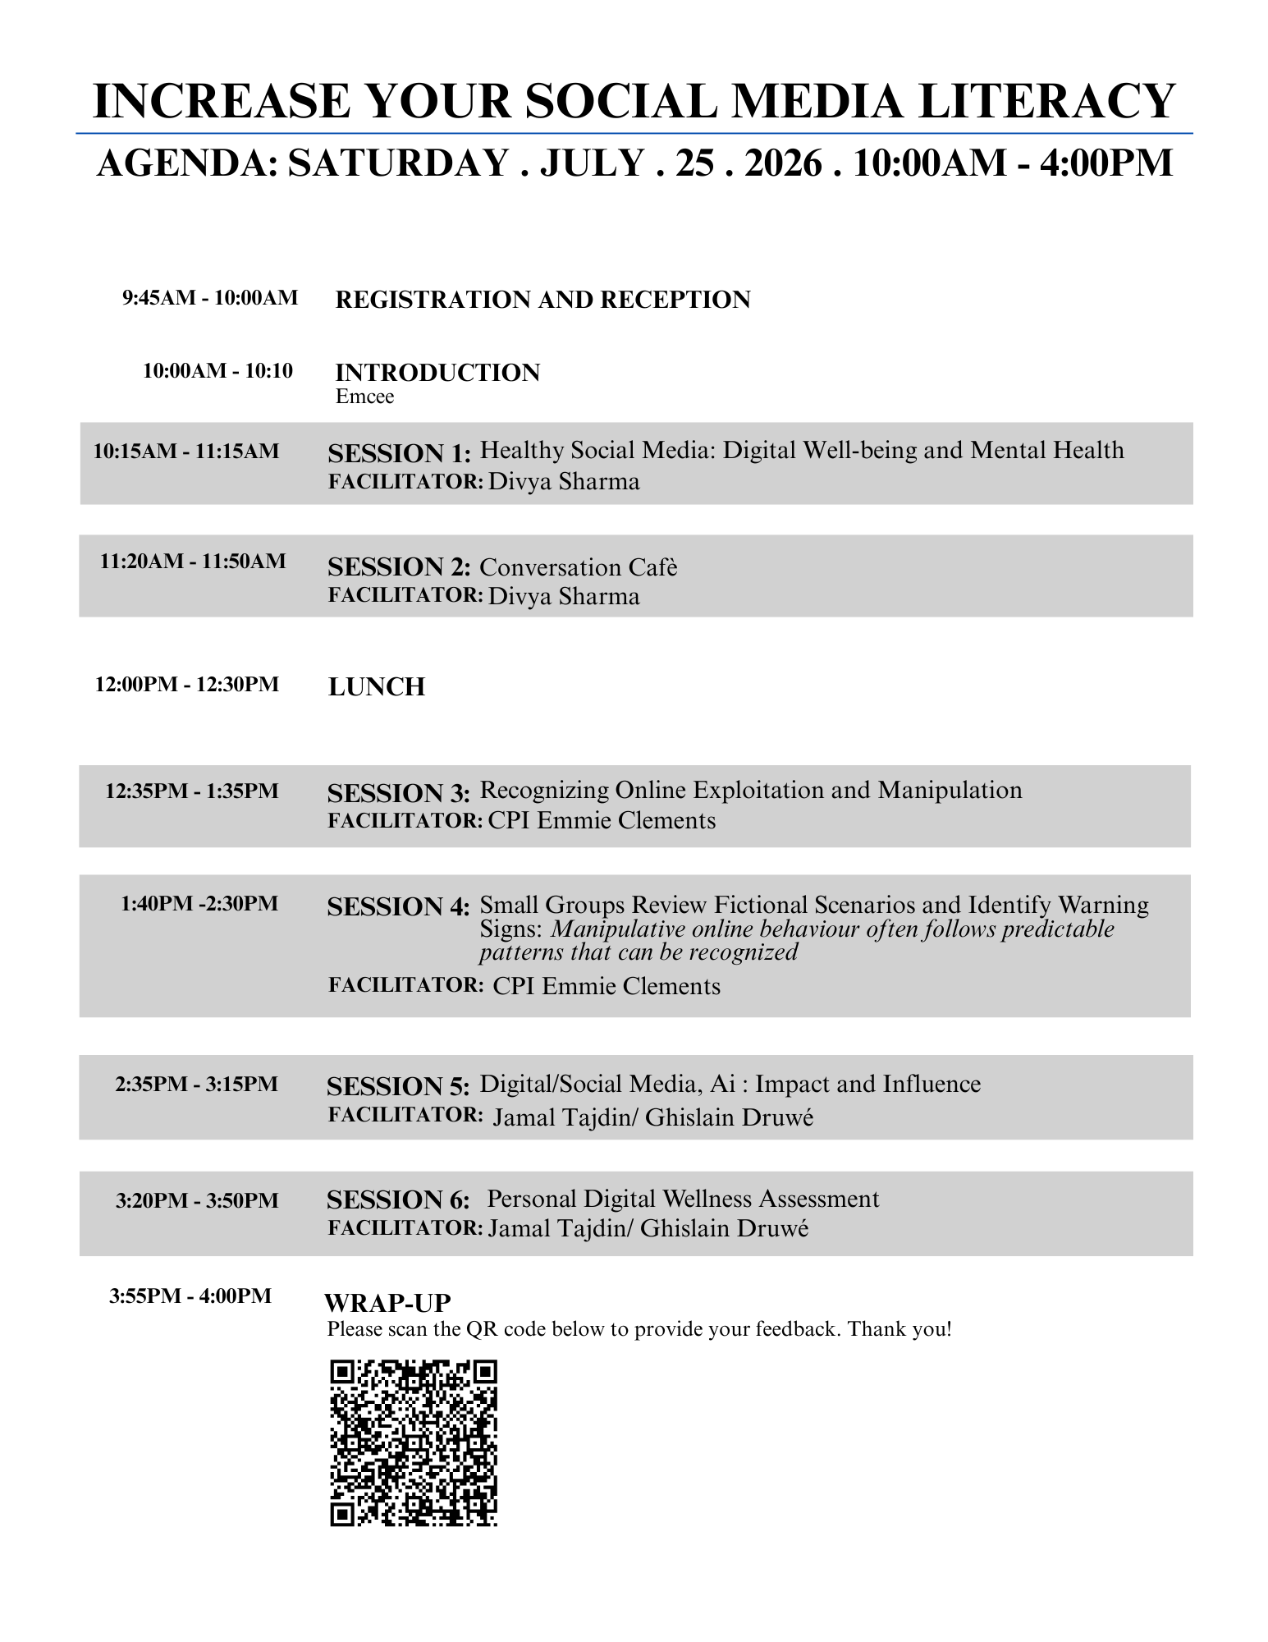

Session 1: Healthy Social Media: Digital Well-being and Mental Health
The first major session was facilitated by Divya Sharma, a youth leader, policy advocate, and UNICEF U-Report Ambassador. The session examined the relationship between social media, attention, digital habits, and mental health.
The presentation began with an interactive screen-time exercise that asked participants to look at their own phone usage. This created an immediate connection between the material and participants' everyday lives. The exercise encouraged participants to look at their own digital behaviour and consider what their screen-time numbers represented.
Divya's presentation then examined why people may find it difficult to stop using social media. The presentation connected natural human tendencies toward accumulation, stimulation, reward, and social recognition with modern digital environments. It explained how social media platforms can turn these tendencies into measurable forms of engagement such as likes, followers, views, shares, and watch time.
A major part of the presentation focused on the dopamine economy and variable rewards. Participants were introduced to the idea that unpredictable rewards can encourage repeated behaviour. Features such as pull-to-refresh, notifications, streaks, and constantly changing feeds were discussed as examples of design features that reduce natural stopping points.
The session also introduced Canadian data concerning internet use, screen time, mental health, phone-checking behaviour, and online harms. These statistics provided a broader context for the individual experiences participants had already begun considering through the opening screen-time exercise.
The presentation then moved into how algorithms operate. Participants learned that recommendation systems can respond to factors such as viewing time, engagement, and emotional reactions. Hyper-personalization can result in different users being shown different content based on their previous behaviour.
The session also examined harmful design patterns such as infinite scroll, autoplay, streaks, and push notifications. Participants were encouraged to think critically about the fact that many digital environments do not provide natural stopping points. Instead, users may have to make an active decision to stop.
The final part of the session focused on building resistance. Participants were introduced to practical strategies including delaying the impulse to open an app, logging out, using greyscale, moving distracting applications away from the home screen, batching social media use, turning off unnecessary notifications, and creating phone-free periods.
The session ended with a reflective activity asking participants to identify a digital habit or notification where they could introduce more friction during the following week.

Session 2: Conversation Café
The second session was facilitated by Divya Sharma.
This session created a discussion on how social media use is not experienced in exactly the same way by every young person. Participants could reflect on their own experiences and consider how their habits, attention, and relationship with technology compare with those of others.
The discussion format also supported the overall goal of the workshop by allowing participants to speak about digital wellbeing rather than only receiving information from facilitators.
The participant feedback later indicated that participants valued interactive discussion and wanted more time for this type of engagement. This suggests that the conversation component was useful and that future versions of the workshop could provide additional time for participant-led discussion.

Session 3: Recognizing Online Exploitation and Manipulation
The third session was facilitated by Cpl. Emmie Clements, a corporal with the Manitoba Integrated Child Exploitation Unit.
This session shifted the focus from the design of social media platforms to the ways people can be manipulated and exploited within online environments.
Participants were introduced to online grooming and manipulative behaviour and learned that exploitation can involve recognizable patterns. The session emphasized the importance of recognizing warning signs and understanding how manipulation can develop through online interactions.
One of the most important aspects of the session was that the information came from a professional working in the area of child exploitation. This provided participants with practical information about online risks rather than relying only on general warnings about social media.
The session also addressed platform features that may make it more difficult for parents or other adults to understand what young people are doing online. The discussion around hidden or less obvious communication features on platforms such as Snapchat stood out in participant feedback.

Session 4: Small-Group Scenario Analysis
The fourth session continued Cpl. Clements' work through small-group scenario analysis.
Participants were asked to review fictional scenarios and identify warning signs associated with manipulative online behaviour. The purpose of this activity was to help participants apply the information from the previous session rather than only listen to a presentation about exploitation. The scenario-based format allowed participants to discuss what they were seeing, identify concerning behaviours, and compare their interpretations with those of other participants.
This interactive component was particularly important because recognizing manipulation is a skill that benefits from practice. Participants were given an opportunity to think through situations that could resemble the kinds of interactions young people may encounter online.
Participant feedback later indicated that participants wanted more time for group discussion. This is especially relevant to Session 4 because it suggests that the scenario and discussion components could be expanded in future workshops.

Session 5: Digital/Social Media, AI: Impact and Influence
The fifth session was facilitated by Jamal Tajdin and Ghislain Druwé and focused on artificial intelligence, synthetic media, algorithms, and the distribution of digital content.
A central part of the session involved examining synthetic media and AI-generated content. Participants were given an opportunity to consider how convincing manipulated or AI-generated content can appear and why it can be difficult to distinguish from authentic media.
The Morgan Freeman AI demonstration was particularly effective in making this issue concrete. Rather than only explaining that AI can produce convincing media, participants were able to see an example and discuss why viewers might believe what they were seeing.
The workshop then divided participants into groups to examine synthetic media from different perspectives.
One group focused on visual cues, asking where lighting, shadows, or other visual elements might break from reality.
A second group focused on algorithmic hooks, considering what emotional triggers might encourage someone to watch or share a particular piece of content.
A third group examined civic trust, considering how synthetic media could affect people's trust in institutions and information.
A fourth group examined the creator perspective, considering how generative technology could save time or money for legitimate media production.
This structure was valuable because it avoided reducing AI to a simple discussion of whether the technology is "good" or "bad." Participants were encouraged to examine how the same technology can have different uses and consequences depending on how it is created, distributed, and consumed.
The session also examined how algorithms can distribute content based on engagement signals such as direct-message shares, saves, video completion rates, likes, and follower activity. Participants learned that content can be tested with smaller groups and then distributed more widely when it receives strong engagement.
This helped connect the AI discussion back to the earlier session on algorithms. The issue was not only whether content was authentic, but also how quickly misleading or emotionally engaging content could spread through an algorithmic system.
The session also introduced participants to questions surrounding metadata, content verification, and digital provenance. Participants were encouraged to understand that the absence of an AI label does not automatically establish that content was created by a human.
This session ended by returning to digital wellness. Participants were encouraged to audit their digital exposure, verify content, filter out unnecessary noise, and create healthier boundaries around their online environments.

Session 6: Personal Digital Wellness Assessment
The sixth session focused on applying the day's learning to participants' own digital habits.
The session encouraged participants to think about the kind of digital environment they wanted to create rather than simply focusing on how much time they spent online.
Participants were encouraged to consider their digital footprint, the types of content they encounter, the reliability of information in their feeds, and the amount of time they spend consuming digital content.
The broader goal was to move participants toward a more intentional relationship with technology. This included identifying habits that may be contributing to excessive or unhelpful screen use, considering what content they want to see more or less of, and thinking about how boundaries can protect offline time.
The session connected directly to the earlier discussion of digital resistance. Participants had already learned about algorithms and design features that encourage continued engagement. The digital wellness assessment gave them an opportunity to consider what they could do in response.
The program concluded with a brief wrap-up and an invitation for participants to provide feedback through the workshop's QR code.

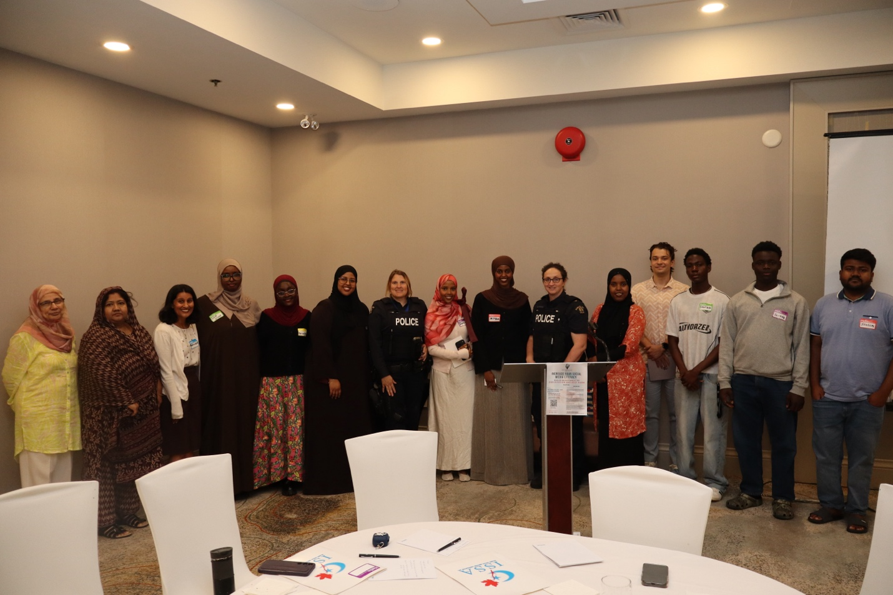
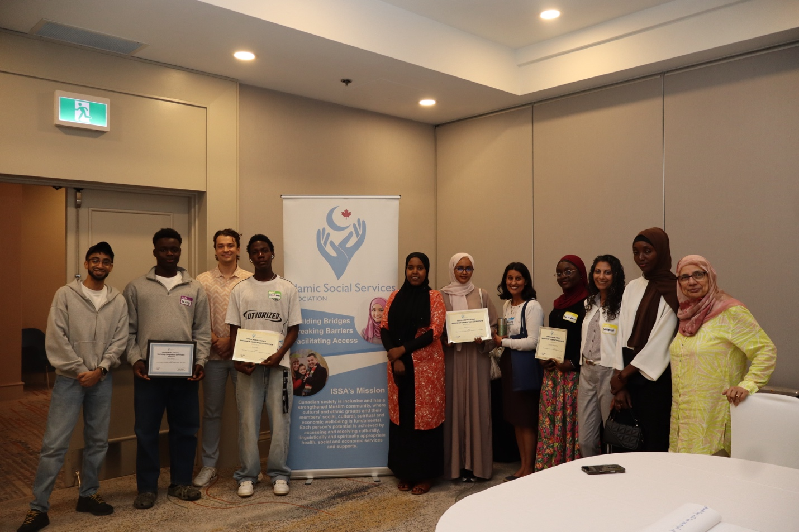

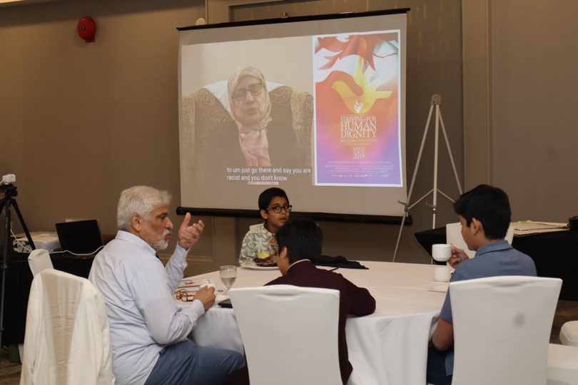
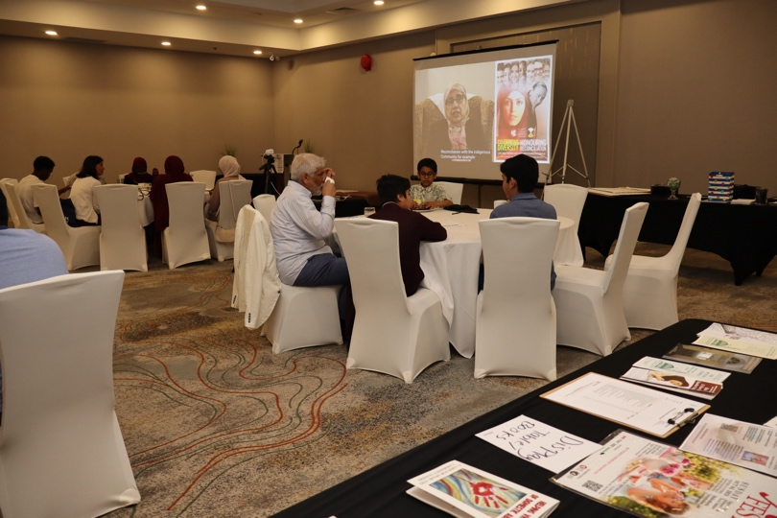
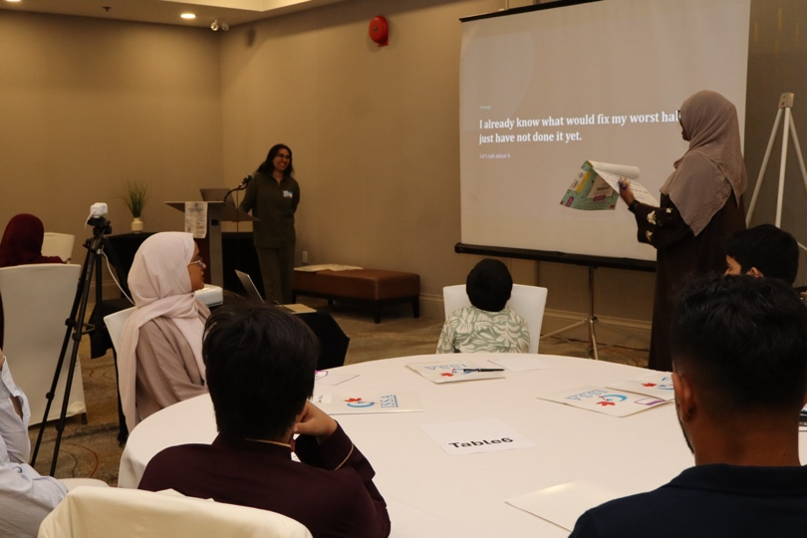
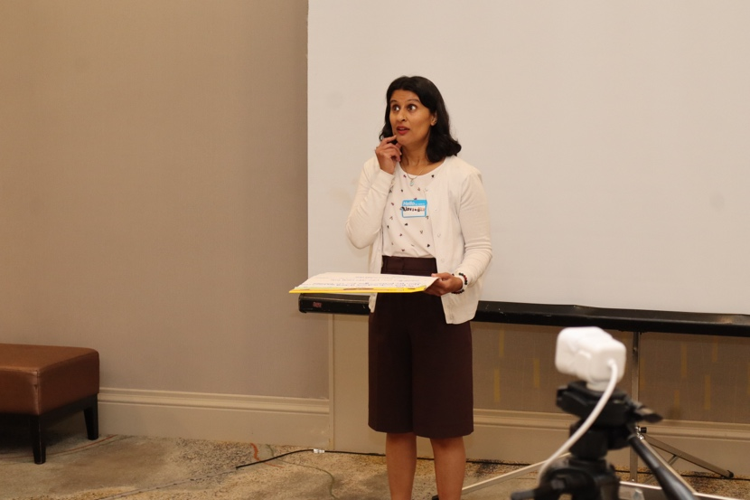
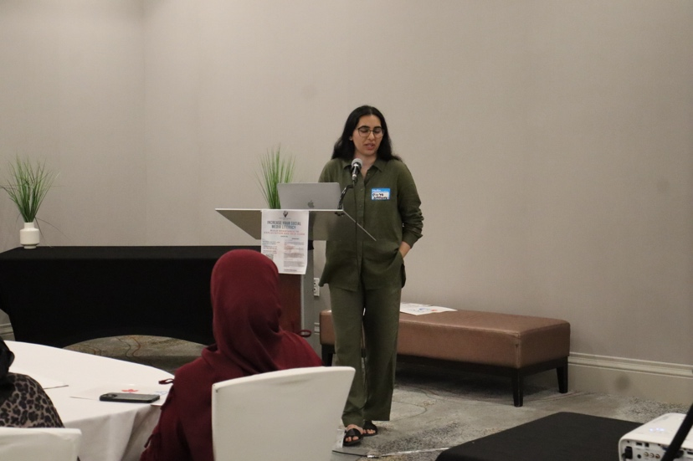
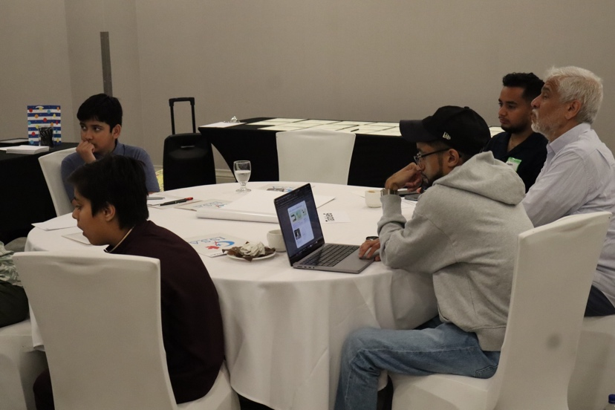
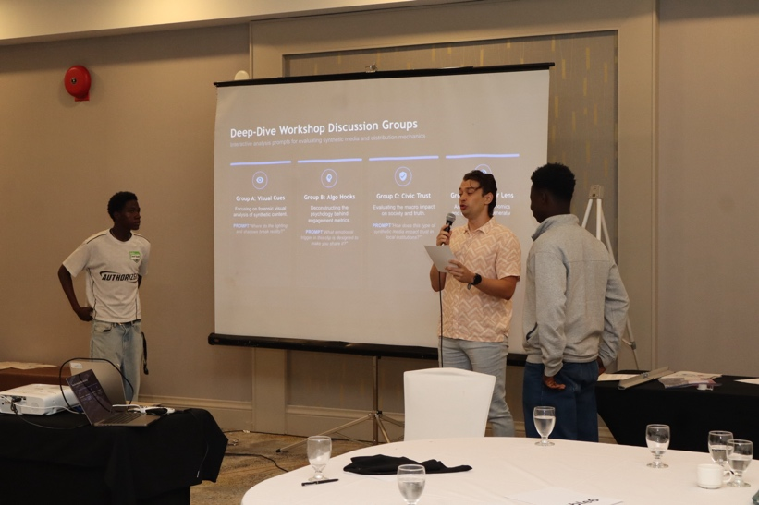
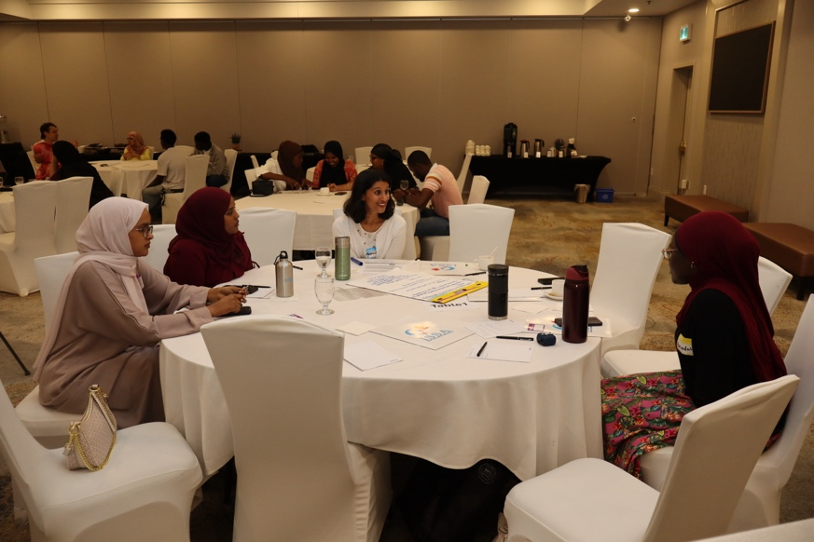
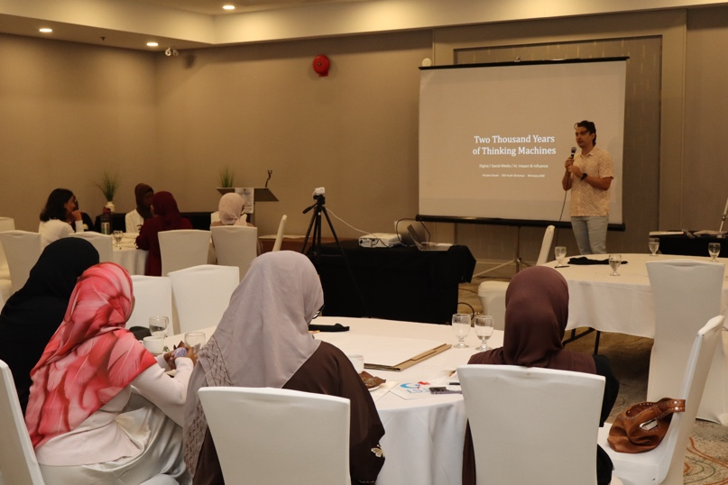
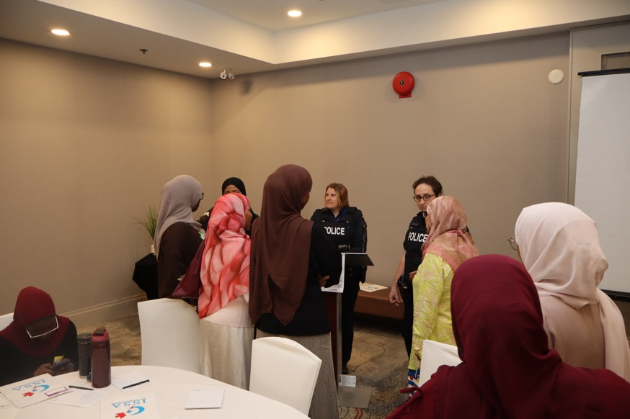
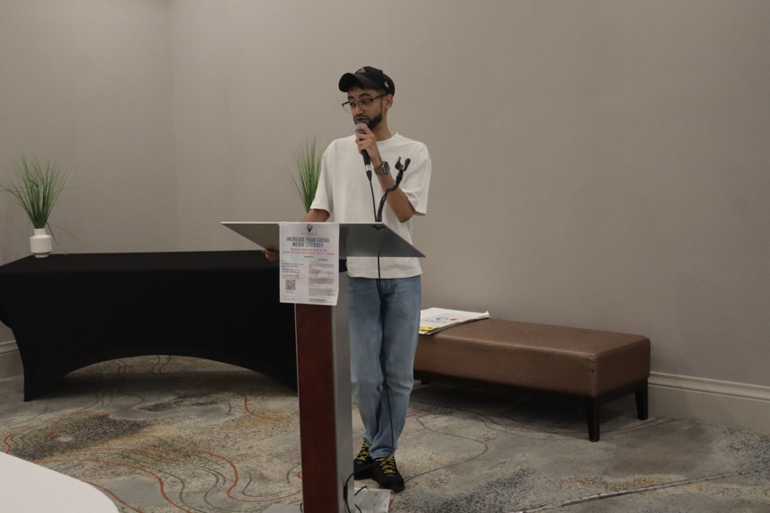
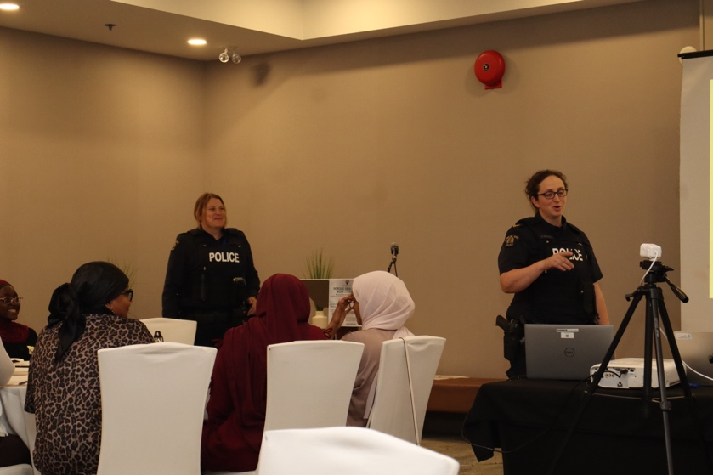
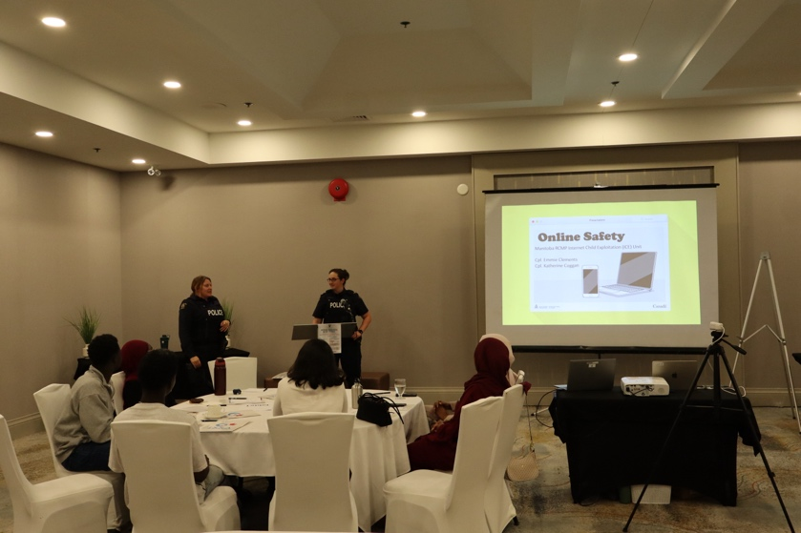
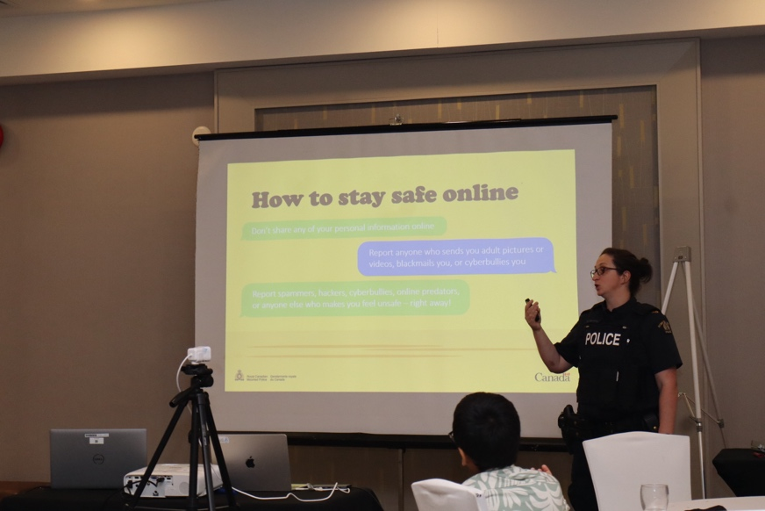
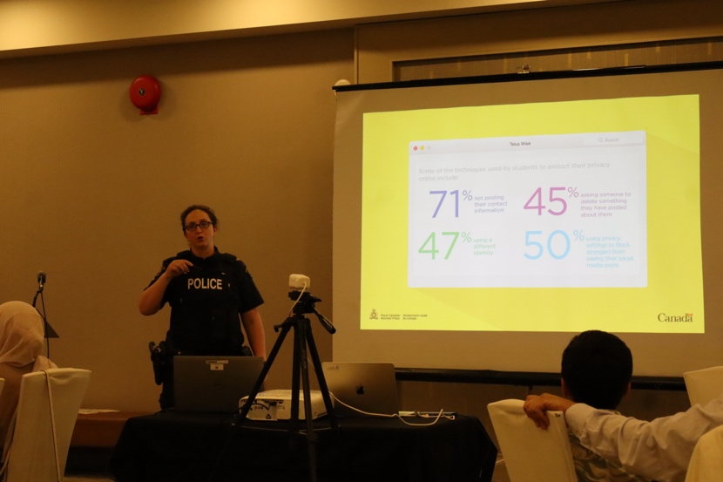
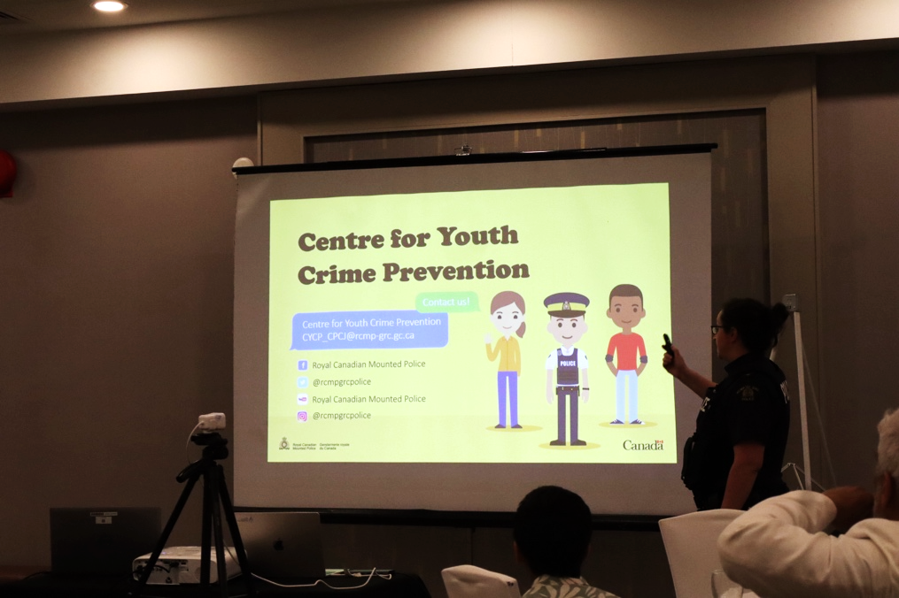

Participants Feedback
We received 8 responses through Microsoft Forms. The average recommendation score was 9.375/10.

Participant 1
- Did the workshop meet your expectations? Please explain
    - Yes, it went way beyond my expectations. I thought it was going to be a basic lecture on screen time, but the practical safety info made it extremely valuable.

- Tell us three things you learned and/or enjoyed today
  - Learning how to recognize online grooming and manipulative behaviors during Cpl. Emmie Clements' RCMP presentation.
  - Discovering that Snapchat has hidden features kids use to conceal secret chats. parents need a session covering this
  - Watching the Morgan Freeman AI deepfake in Jamal session and seeing how easily people can be tricked.
- Were your expectations of the event met? Beyond my expectations
- What or which session did you like most about the event? Session 3 with Cpl. Emmie Clements on recognizing online exploitation.
- How likely are you to recommend the event to a friend or colleague? [10]
- How could the event be improved? Organize a dedicated evening session specifically for parents so they can learn about these app features.

Participant 2
- Did the workshop meet your expectations? Please explain
  - exceeded what I expected. Getting to see real AI generation in action and analysing how algorithms push viral content was eye-opening.
- Tell us three things you learned and/or enjoyed today
  - Sitting at our breakout tables to evaluate different concepts like visual cues and algorithm hooks.
  - Hearing the RCMP warning about hidden chat features on Snapchat that keep parents in the dark.
- Were your expectations of the event met? Meet my expectations
- What or which session did you like most about the event? Session 5 on AI's Impact and Influence.
- How likely are you to recommend the event to a friend or colleague? [10]
- How could the event be improved?
  - Give us a bit more time for the group discussions because the debate at our table was really engaging.

Participant 3
- Did the workshop meet your expectations? Please explain
  - Yes, it met my expectations. I hoped it will be more interactive at the beginning
- Tell us three things you learned and/or enjoyed today
  - Discussing the Morgan Freeman AI clip and learning how video deepfakes are produced and distributed.
- Were your expectations of the event met? Beyond my expectations
- What or which session did you like most about the event? Session 1 of Divya explaining how the algorithm hooks on just because I stayed on a videos few second. Could have been something that disgusted me but still doesn’t understand what I actually enjoy
- How likely are you to recommend the event to a friend or colleague? [8]
- How could the event be improved? Give us a takeaway flyer summarizing privacy settings and red flags that we can share with others.

Participant 4
- Did the workshop meet your expectations? Please explain
  - It helped me understand the “machine” reasons behind why we get addicted to our phones.
- Tell us three things you learned and/or enjoyed today
  - Divya Sharma’s session on dopamine loops, infinite scroll, and how algorithms trigger constant cravings and seeing the AI video examples like Morgan Freeman and discussing how easy it is to deceive people online.
- Were your expectations of the event met? Beyond my expectations
- What or which session did you like most about the event? Session 1 on Healthy Social Media and Digital Well-being.
- How likely are you to recommend the event to a friend or colleague? [10]
- How could the event be improved? maybe a quick practical exercise where everyone sets up screen-time limits on their phones right during the talk. I really liked when one trainer had asked to open our phone and what are the things that came up on our phone

Participant 5
- Did the workshop meet your expectations? Please explain
  - Yes, it was super informative and very relevant to everyday life.
- Tell us three things you learned and/or enjoyed today
  - The Morgan Freeman AI clip in Jamal talk showing how convincing fake videos can be.
- Were your expectations of the event met? Met as expected
- What or which session did you like most about the event? The AI demonstration with Jamal
- How likely are you to recommend the event to a friend or colleague? [7]
- How could the event be improved? Bring the exact presentation into local high schools so more youth can see it.

Participant 6
- Did the workshop meet your expectations? Please explain
  - It made me look at social media algorithms and AI content completely differently.
- Tell us three things you learned and/or enjoyed today
  - How algorithm test and push content using DM shares and saves or how long we watch even for few seconds.
- Were your expectations of the event met? Beyond my expectations
- What or which session did you like most about the event? Session 5 AI Impact and Influence.
- How likely are you to recommend the event to a friend or colleague? [10]
- How could the event be improved? Hold a joint workshop where youth and parents can attend together.

Participant 7
- Did the workshop meet your expectations? Please explain Yes
- Tell us three things you learned and/or enjoyed today
- The overwhelming negatives that comes with the advent of social media
- Were your expectations of the event met? Beyond my expectations
- What or which session did you like most about the event? Session 5 and 6
- How likely are you to recommend the event to a friend or colleague? 10
- How could the event be improved?
- More people involved so it's more interactive and filled with more opinions

Participant 8
- Did the workshop meet your expectations? Please explain
  - Yes
- Tell us three things you learned and/or enjoyed today Online safety, How to avoid it
- Were your expectations of the event met? Met as expected
- What or which session did you like most about the event? The ai part
- How likely are you to recommend the event to a friend or colleague? 10
- How could the event be improved? More people attending

Outcome of the Workshop
1. Understanding Digital Well-being and Algorithms
- Several participants specifically identified Divya Sharma's session as one of the most valuable parts of the workshop.
- Participant 4 said the workshop helped them understand the “machine” reasons behind why we get addicted to our phones. This response is particularly important because understanding the mechanisms behind digital engagement was a central purpose of Session 1.
- The participant also specifically identified Divya's discussion of dopamine loops, infinite scroll, and algorithms as something they learned from and enjoyed.
- Participant 3 similarly identified the explanation of how algorithms respond to viewing behaviour as their favourite part of Session 1. They reflected on how simply remaining on a video for a few seconds can influence what the algorithm presents afterward.
- This suggests that participants were not only hearing that algorithms influence their feeds. They were beginning to recognize how their own actions, including viewing time, can become signals used by recommendation systems.
- Participant 6 made a similar observation, explaining that they learned how algorithms test and push content using signals such as direct-message shares, saves, and how long someone watches a video, even for a few seconds.
- These responses demonstrate that the workshop successfully introduced participants to specific mechanisms of algorithmic influence rather than leaving the concept of "the algorithm" as something vague.

2. AI and Synthetic Media Were Particularly Memorable
- The AI component was one of the clearest themes across the participant feedback.
- Participants repeatedly mentioned the Morgan Freeman AI demonstration and the discussion of synthetic media.
- Participant 1 described learning how easily people can be tricked after watching the AI deepfake demonstration.
- Participant 2 said that seeing AI generation in action and examining how algorithms push viral content was eye-opening.
- Participant 3 said they enjoyed discussing the Morgan Freeman AI clip and learning how video deepfakes are produced and distributed.
- Participant 4 also mentioned the AI video examples and how easy it can be to deceive people online.
- Participant 5 specifically identified the AI demonstration with Jamal as the session they liked most.
- Participant 6 selected Session 5: AI Impact and Influence as their favourite session.
- Participant 8 also identified the AI portion as their favourite part of the workshop.
- The repeated references to the AI demonstration suggest that the use of a concrete example was particularly effective. Participants were able to see a convincing piece of synthetic media rather than only hearing an abstract explanation of deepfakes.
- The feedback also shows that participants connected the demonstration to a broader concern about trust and deception. They recognized that the problem is not simply that AI can create fake content, but that the content may be convincing enough to influence viewers who do not know how it was created.

3. Online Exploitation and Manipulation
- The session led by Cpl. Emmie Clements was another clear area of interest.
- Participant 1 identified Session 3 on recognizing online exploitation as their favourite session. They specifically mentioned learning how to recognize online grooming and manipulative behaviours.
- Participant 2 also remembered the information about hidden chat features on Snapchat and the way these features can make it more difficult for parents to understand children's online interactions.
- This feedback suggests that participants valued information that was directly connected to the platforms and situations they may encounter.
- The comments also point toward an important distinction between general online safety advice and practical knowledge. Participants appeared to value learning specific behaviours and warning signs that they could recognize rather than simply being told that social media can be dangerous.

4. Interactive Learning Was Valued, but Participants Wanted More of It
- One of the areas for improvement was the amount of time available for interactive activities.
- Participant 2 said they wanted more time for group discussions, explaining that the debate at their table was engaging.
- Participant 3 said they had hoped the workshop would be more interactive at the beginning.
- Participant 4 suggested that participants could complete a practical exercise during the workshop, such as setting screen-time limits directly on their phones.
- Participant 7 suggested involving more people so that the workshop could include more opinions and interaction.
- These comments are consistent with the design of the workshop. The sessions that required participants to examine their own phones, discuss scenarios, analyze synthetic media, or work together provided opportunities for participants to actively engage with the material.
- The feedback suggests that future workshops should not simply add more information. They should consider using some of the available time for more practice, discussion, and direct application.

5. Participants Wanted Practical Resources They Could Use After the Workshop
- Participant 3 suggested providing a takeaway flyer that summarizes privacy settings and online warning signs so participants could share the information with others.
- This suggestion is particularly relevant to the workshop because much of the material involved information that participants could apply outside the event.
- A short resource could summarize:
- warning signs of online grooming and manipulation;
- privacy and safety settings;
- signs that digital media may be manipulated or AI-generated;
- basic strategies for managing screen time;
- ways to create friction around distracting apps;
- strategies for verifying information before sharing it; and
- relevant support resources.
- Providing such a resource would also allow participants to share the information with family members and friends who did not attend the workshop.

6. Interest in Parent and Youth Programming
- Several participants suggested expanding the workshop to other audiences.
- Participant 1 suggested a dedicated evening session for parents so they could better understand app features and online risks.
- Participant 5 suggested bringing the presentation into local high schools so more youth could access the material.
- Participant 6 suggested a joint workshop for youth and parents.
- These suggestions indicate that participants saw value in the workshop beyond the original event. They also point to a specific community education need around the gap between young people's use of digital platforms and adults' understanding of those platforms.
- The feedback does not necessarily mean that the original youth-focused format should be changed. Rather, it suggests that the workshop could become the foundation for additional programming designed for parents, schools, or mixed youth-parent audiences.

Conclusion
This Media Literacy workshop successfully created a meaningful learning space where youth could critically examine how digital platforms shape attention, behaviour, and decision-making. Across the sessions, participants developed a stronger understanding of how algorithms influence what they see, how features such as infinite scroll and notifications affect online habits, how predictable behaviours can be exploited online, and how AI-generated and synthetic media can challenge trust in digital information. The strong participant feedback and high recommendation scores indicate that the workshop was relevant, engaging, and valuable to those who attended.
A key strength of the program was its progression from personal digital habits to broader systemic issues. Participants were able to connect their own screen use to platform design, identify real-world risks such as manipulation and grooming, and critically engage with emerging technologies, including AI and deepfakes. Interactive components, particularly group discussions, scenario-based activities, and the AI demonstration, were consistently identified as some of the most memorable and valuable elements of the workshop.
Participants’ feedback provides a clear direction for future programming. Rather than adding more content, future workshops would benefit from creating more opportunities for active, hands-on learning. Participants could directly apply strategies such as adjusting phone settings, reviewing screen-time habits, managing notifications, and practicing digital verification skills during the session. Additional time for group discussion and scenario-based activities would also allow participants to explore complex issues more deeply and strengthen their ability to apply what they have learned to real-life situations.
Participants also identified the value of practical take-home resources, including simple guides on online safety, AI awareness, privacy settings, and digital wellness. These resources could help reinforce learning after the workshop and provide participants with tools they can share with peers and family members. The interest in expanding programming to parents, schools, and joint youth–parent sessions also points to a

broader community need for shared understanding of the digital environments young people navigate every day.
Future evaluation could further strengthen the program by moving beyond satisfaction and recommendation ratings to include simple pre- and post-workshop measures. These measures could help assess changes in participants’ knowledge, confidence, and ability to apply digital literacy and online safety strategies in their everyday lives.
ISSA extends its sincere appreciation to everyone who contributed to the success of the Increase Your Social Media Literacy workshop. Special thanks are extended to Divya Sharma for leading sessions on healthy social media use, digital wellbeing, mental health, and algorithmic influence, and for guiding participants in reflecting on their own digital habits.
ISSA extends its sincere appreciation to Divya Sharma, Cpl. Emmie Clements, Jamal Tajdin, and Ghislain Druwé for their contributions to the success of the workshop.
ISSA also acknowledges the support of the Canadian Race Relations Foundation, which helped make this workshop possible.
Most importantly, ISSA thanks the youth participants whose questions, engagement, and reflections shaped the workshop. Their feedback demonstrated both a strong interest in these issues and a clear need for continued opportunities to build digital literacy and critical thinking skills. Their contributions will help guide the development of future programming.



000

Contact Information
Islamic Social Services Association (ISSA)
1200-191 Lombard Ave
Winnipeg, MB
R3B 0X1
204-944-1560
Phone: 204-944-1560
Website: www.issacanada.com
Email: info@issacanada.com

