Introduction
The Islamic Social Services Association (ISSA), in partnership with Ma Mawi Wi Chi Itata Centre, hosted Truth and Reconciliation: Indigenous & Muslim Youth Conversations on Saturday, June 6, 2026, at the Gathering Place for Truth and Reconciliation, 445 King Street in Winnipeg. The event was designed for youth ages 16 and older as a space for learning, cultural sharing, reflection, and relationship-building between Indigenous and Muslim communities.
The purpose of the gathering was to move beyond general conversations about reconciliation and create a space where participants could learn directly from Indigenous Elders, Knowledge Keepers, cultural presenters, and community members. The event also gave Muslim participants space to share parts of their own experiences, including questions and conversations around prayer, hijab, identity, community, and common misunderstandings.
The event was planned as a community gathering where people could sit together, ask questions respectfully, listen to lived experiences, and think about what allyship looks like in real life. This mattered because reconciliation cannot only happen through information. It also needs trust, listening, and relationships.
The event was also planned with accessibility in mind. Lunch was included, and bus tickets were available for participants who needed transportation support. This helped reduce barriers and made it easier for youth to attend and stay engaged throughout the afternoon.

Goals of the Event
This event reflected ISSA’s longstanding commitment to education, advocacy, and community care. Building on the organization’s work since 1999, the event brought Indigenous and Muslim youth together to learn directly from one another, address misconceptions, and begin building respectful relationships between their communities.
The first goal was to create a welcoming and respectful space where Indigenous and Muslim youth could meet and have honest conversations. Young people may form assumptions about other communities based on what they encounter through the media, school, social media, or other people. The event gave participants an opportunity to ask questions directly, share their perspectives, and learn from one another instead of relying on stereotypes or incomplete information.
The second goal was to give Muslim youth an opportunity to learn directly from Indigenous community members and knowledge holders. Through teachings about smudging and traditional medicines, traditional Powwow dance, and small-group discussions, participants learned about Indigenous cultures, spiritual and healing practices, and lived experiences. These activities allowed Indigenous participants and facilitators to share knowledge in their own voices and helped Muslim youth develop a more respectful understanding of Indigenous traditions and experiences.
The third goal was to create space for Muslim youth to share their identities, beliefs, and lived experiences with Indigenous participants. The discussions addressed common questions and misconceptions about Muslims, including why some Muslim women wear the hijab while others do not, the spiritual meaning of the hijab, and the different ways Muslim identity may be understood and expressed. Muslim youth were able to answer questions in their own words and explain that there is no single way of experiencing or expressing Muslim identity.
The final goal was to encourage Indigenous and Muslim youth to reflect on allyship and how their communities could support one another beyond the event. Participants were encouraged to understand that allyship involved more than saying the right things. It required listening, learning, respecting cultural and religious differences, challenging stereotypes, and continuing to build relationships over time.

Program and Activities
The day began with arrival, registration, and lunch. This gave participants time to settle into the space before the formal program began. The room was set up in a way that encouraged conversation, with participants sitting at round tables rather than in rows. This helped create a more relaxed environment where people could speak with one another instead of only listening from a distance.
The opening included remarks from ISSA and Ma Mawi Wi Chi Itata Centre, along with a land acknowledgement. Noir Masri served as the emcee and helped guide the flow of the day. The opening helped explain why the gathering was taking place and reminded participants that the space was meant for respectful learning, listening, and dialogue.
One of the first major parts of the event was the Indigenous smudging and medicine teaching. Participants learned about how smudging is used for healing and reflection. The teaching included cultural items and medicines, helping participants understand that these practices are not only symbolic, but connected to wellness, ceremony, identity, and community care. This session stood out strongly in participant feedback. Participants later mentioned learning about smudging, plant medicines, and healing as some of the most meaningful parts of the event.
The event also included Powwow traditional dance shared by Kristen Pruden, Ynonna Bear, Jayden Bear, and Keagan Gaywish. The dance presentation allowed participants to experience Indigenous culture through movement, regalia, and storytelling. It was not only a performance. It was also a learning moment where participants could see the beauty, discipline, and meaning connected to Powwow dance. Several participants later identified the Powwow dance as their favourite part of the event, describing it as powerful, memorable, and incredible to watch.
A central part of the event was the small-group conversations. Participants were divided into two groups. One group was led by Elder David Budd, and the other was led by Christina Leask from Ma Mawi Wi Chi Itata Centre. These conversations were more personal than formal presentations. Elder David Budd and Christina Leask shared Indigenous teachings, sacred knowledge, lived experiences, and reflections from their communities.
The conversations also invited participants to think about stereotypes and misconceptions. Indigenous facilitators shared examples of assumptions that Indigenous people continue to face, and participants were encouraged to think about where those ideas come from and how harmful they can be. This gave participants a chance to learn about Indigenous experiences in a direct and respectful way.
The discussion also moved both ways. Participants were asked about myths and stereotypes people may have heard about Muslims. This opened up questions about hijab, Muslim prayer, religious practice, and identity. Muslim participants explained that hijab can carry spiritual meaning for many women, but that Muslim women do not all practise or dress in the same way. The discussion helped participants understand that Muslim identity is not one single experience, and that assumptions about Muslim women, faith, or culture can be limiting and harmful.
This part of the event was especially meaningful because it allowed both communities to learn from each other directly. Instead of only talking about diversity in general terms, participants were able to ask real questions and hear real answers from people in the room.
The event ended with a closing circle focused on what allyship looks like. Elder Geraldine “Gramma” Shingoose and Omar Siddiqui contributed during the closing circle. Gramma Shingoose’s presence helped ground the gathering in truth, lived experience, and care. As a respected Saulteaux/Anishinaabe Elder, Residential School Survivor, Knowledge Keeper, educator, and advocate, her role brought depth to the conversation about reconciliation and healing.
The closing circle gave participants a chance to reflect on what they learned and what they were taking with them. This was important because the event was not only about attending activities. It was about leaving with a better understanding of how communities can continue showing up for one another.

Participant Feedback
The participant feedback showed that the event was meaningful, welcoming, and impactful. Out of the ten responses collected, most participants said the event either met or went beyond their expectations. Several participants explained that they did not know what to expect at first, but found the space more welcoming and engaging than they expected.
One participant said the event did not simply meet their expectations, but exceeded them because they enjoyed the dancing and listening to the Elders. Another participant said the event went beyond what they expected because they “didn’t think we’d get so close so fast.” This response shows that the event was not only educational. It also helped participants feel connected to others in the room.
A strong theme in the feedback was appreciation for Indigenous teachings. Participants repeatedly mentioned the medicine teachings, smudging, and Elder wisdom. One participant said they enjoyed “the medicine session with the elder,” while another said their favourite part was learning about different plant medicines. Others said they learned how smudging is used for healing and that the smudging session at the start was the part they liked most.
This feedback shows that participants were not only interested in learning about Indigenous practices from the outside. They valued being taught directly by Indigenous community members. The medicine and smudging teachings helped participants understand Indigenous healing practices in a more personal and respectful way.
The Powwow Traditional Dance was another major highlight. Several participants identified it as one of the strongest parts of the event. One participant said the Powwow Traditional Dance was “incredible to watch,” while another said it was “spectacular to see live.” Participants also said they enjoyed the dancing of the Indigenous community and learned about Indigenous dance history.
This shows that the dance presentation had a strong impact because it brought learning into the space visually and emotionally. Participants were not only hearing about culture, but seeing cultural expression shared directly with them.
The community conversations were also an important part of the feedback. Participants said they appreciated the open discussions and the conversation around “What I wish people understood about my community.” One participant said their favourite part was the community conversation where “we all shared.” Another said they liked learning about “how much our communities share in common.”
This feedback matters because it shows that participants valued the chance to speak, not only listen. The conversations helped participants reflect on their own experiences while also learning from others. The event created space for participants to think about stereotypes, identity, community, and what people often misunderstand about one another.
Participants also identified allyship as a key learning outcome. Several participants said they learned about what allyship looks like, how to be a real ally, and the importance of listening to others. One participant described the closing circle as powerful, while another said they appreciated hearing Elder Geraldine speak. This shows that the closing circle helped bring the day together and gave participants a way to reflect on the meaning of the gathering.
The feedback also showed that participants appreciated the overall environment. Some described the event as respectful, grounding, emotional in a good way, and a safe space to talk. This is important because events that ask people to discuss identity, stereotypes, and reconciliation need to feel safe enough for people to participate honestly.
The recommendation scores were also strong. Most participants rated the event between 9 and 10 out of 10 when asked how likely they were to recommend it to a friend or colleague. This suggests that participants saw the event as valuable and worth continuing.

Please view the next page to read participants’ comments

Participants Feedback

*Feedback format collected: Microsoft Forms
Saturday, June 6, 2026 | 12:00 PM – 4:30 PM
Gathering Place for Truth and Reconciliation | 12:00 PM – 4:30 PM

Participant 1
- 1. Did the workshop meet your expectations? Please explain: No, it did not meet my expectation but it exceeded it. I enjoyed dancing and listening to the elders.
- 2. Tell us three things you learned and/or enjoyed today: The medicine session with the elder, the dancing of the indigenous community and the conversations.
- 3. Were your expectations of the event met?: Beyond my expectations
- 4. What or which session did you like most about the event?: I liked the Elder teachings about the different plant medicines.
- 5. How likely are you to recommend the event to a friend or colleague?: 10
- 6. How could the event be improved?: Perhaps next time, lets see muslim dancers too. And more indigenous youth and also please advertise the events you guys have online so i am able to share it with other members and community friends.

Participant 2
- 1. Did the workshop meet your expectations? Please explain: Yeah it did, honestly went beyond what I expected. I just didn't think we'd get so close so fast.
- 2. Tell us three things you learned and/or enjoyed today: Loved the Powwow Traditional Dance, learned how smudging is used for healing, and the lunch was really good.
- 3. Were your expectations of the event met?: Beyond my expectations
- 4. What or which session did you like most about the event?: The Powwow Traditional Dance was incredible to watch.
- 5. How likely are you to recommend the event to a friend or colleague?: 10
- 6. How could the event be improved?: Give us a bit more time for the community conversations because it felt a little rushed at the end!

Participant 3
- 1. Did the workshop meet your expectations? Please explain: Met as expected. It was really nice hearing from different people.
- 2. Tell us three things you learned and/or enjoyed today: Elder Geraldine's wisdom, meeting new youth, and learning about allyship.
- 3. Were your expectations of the event met?: Met as expected
- 4. What or which session did you like most about the event?: The closing circle with Gramma Shingoose and Omar.
- 5. How likely are you to recommend the event to a friend or colleague?: 9
- 6. How could the event be improved?: Maybe a slightly longer break in the middle because the schedule was tight.

Participant 4
- 1. Did the workshop meet your expectations? Please explain: Yes fully! I didn't know what to expect but it was so welcoming.
- 2. Tell us three things you learned and/or enjoyed today: Learned about Muslim prayer times, loved the lunch, and liked the open discussions.
- 3. Were your expectations of the event met?: Beyond my expectations
- 4. What or which session did you like most about the event?: The "What I wish people understood about my community" conversation.
- 5. How likely are you to recommend the event to a friend or colleague?: 10
- 6. How could the event be improved?: The room was a bit chilly, maybe turn down the AC next time.

Participant 5
- 1. Did the workshop meet your expectations? Please explain: Yes, it was really educational and emotional in a good way.
- 2. Tell us three things you learned and/or enjoyed today: Learned about smudging for healing, enjoyed the emcee's energy, and learned about actual allyship.
- 3. Were your expectations of the event met?: Met as expected
- 4. What or which session did you like most about the event?: The Indigenous Smudging session at the start.
- 5. How likely are you to recommend the event to a friend or colleague?: 8
- 6. How could the event be improved?: Wish it was a whole day event, 4 hours went by too fast.

Participant 6
- 1. Did the workshop meet your expectations? Please explain: Beyond my expectations, I made some new friends already.
- 2. Tell us three things you learned and/or enjoyed today: The traditional dance, how much our communities share in common, and the food.
- 3. Were your expectations of the event met?: Beyond my expectations
- 4. What or which session did you like most about the event?: The Powwow dance was spectacular to see live.
- 5. How likely are you to recommend the event to a friend or colleague?: 10
- 6. How could the event be improved?: Maybe do an icebreaker game right at 12 to get everyone talking.

Participant 7
- 1. Did the workshop meet your expectations? Please explain: Yeah, it was super cool and very respectful.
- 2. Tell us three things you learned and/or enjoyed today: Smudging practices, Muslim traditions, and what allyship looks like.
- 3. Were your expectations of the event met?: Met as expected
- 4. What or which session did you like most about the event?: The closing circle was really powerful.
- 5. How likely are you to recommend the event to a friend or colleague?: 9
- 6. How could the event be improved?: Send out the bus ticket info a little sooner if possible!

Participant 8
- 1. Did the workshop meet your expectations? Please explain: It did! Very grounding experience.
- 2. Tell us three things you learned and/or enjoyed today: Hearing the youth stories, learning about healing, and Modou's jokes.
- 3. Were your expectations of the event met?: Met as expected
- 4. What or which session did you like most about the event?: The community conversation part where we all shared.
- 5. How likely are you to recommend the event to a friend or colleague?: 10
- 6. How could the event be improved?: More snacks during the afternoon break please!

Participant 9
- 1. Did the workshop meet your expectations? Please explain: Totally, I learned way more than I thought I would.
- 2. Tell us three things you learned and/or enjoyed today: Meaning behind smudging, importance of prayer times, how to be a real ally.

- 3. Were your expectations of the event met?: Beyond my expectations
- 4. What or which session did you like most about the event?: The talk about what we wish people understood about us.
- 5. How likely are you to recommend the event to a friend or colleague?: 10
- 6. How could the event be improved?: Put up a bigger sign outside the building, I got lost for a second.

Participant 10
- 1. Did the workshop meet your expectations? Please explain: Yes it was great, very safe space to talk.
- 2. Tell us three things you learned and/or enjoyed today: Enjoyed the lunch, learned about Indigenous dance history, loved the final speakers.
- 3. Were your expectations of the event met?: Met as expected
- 4. What or which session did you like most about the event?: Hearing Elder Geraldine speak.
- 5. How likely are you to recommend the event to a friend or colleague?: 9
- 6. How could the event be improved?: Maybe smaller discussion circles so quieter people can speak more.

What Can Be Improved
The event was successful, but the feedback shows that future gatherings can be stronger with a few clear changes.
First, future events should allow more time for community conversations. Several participants said they wanted more time for discussion and felt the conversation portion was rushed near the end. Since the conversations were one of the strongest parts of the event, future sessions should make this section longer or reduce the number of activities so participants have more time to speak, ask questions, and listen to one another.
Second, future events should include more youth from both Indigenous and Muslim communities. One participant specifically suggested inviting more Indigenous youth. Another suggested advertising the events more online so they could share them with friends and community members. This shows that participants were not only satisfied with the event, but wanted more people to have access to the same experience.
Third, future events could begin with an icebreaker. One participant suggested starting with an icebreaker at 12:00 PM to help everyone begin talking earlier. This would be useful because the event depends on trust and conversation. A simple opening activity could help participants feel more comfortable before the deeper conversations begin.
Fourth, communication around transportation and logistics can be improved. One participant suggested sending bus ticket information earlier. Another said there should be a bigger sign outside the building because they got lost. These details may seem small, but they affect how prepared and comfortable participants feel when attending.
Fifth, the schedule should allow a longer break or more time between activities. One participant said the schedule felt tight, while another said they wished the event was a whole-day gathering because four hours went by too quickly. This feedback suggests that participants were engaged and wanted more time with the material.
Sixth, future discussion circles could be smaller. One participant suggested smaller circles so quieter people can speak more. This is a helpful point because larger groups can make it harder for some participants to share. Smaller circles may help create a more balanced conversation.

Acknowledgements
ISSA would like to thank Ma Mawi Wi Chi Itata Centre for partnering on this gathering and for helping create a welcoming space for Indigenous and Muslim youth to learn together.
Special thanks to Elder Geraldine “Gramma” Shingoose for sharing her wisdom, presence, and teachings. Her role helped ground the event in truth, healing, and lived experience.
Thank you to Christina Leask and Elder David Budd for leading the group conversations and sharing Indigenous teachings, experiences, and reflections with participants.
Thank you to Kristen Pruden, Ynonna Bear, Jayden Bear, and Keagan Gaywish for sharing Powwow traditional dance and helping participants learn through cultural expression.
Thank you to Noir Masri for serving as the emcee and helping guide the program throughout the afternoon.
Thank you also to Omar Siddiqui for contributing during the closing circle.
Most importantly, thank you to the participants. Their openness, questions, respect, and willingness to engage are what made the gathering meaningful. The success of the event came from their listening, their reflections, and the care they brought into the space.

Next Steps
The strongest outcome of Truth and Reconciliation: Indigenous & Muslim Youth Conversations was that participants felt comfortable enough to learn, ask questions, and connect with people from another community. The feedback shows that youth valued the space and wanted more opportunities like it.
The next step should be to continue this work as more than a one-time event. Future sessions could include longer discussion circles, more teachings from Elders and Knowledge Keepers, more Indigenous and Muslim youth participation, and continued conversations about identity, stereotypes, healing, and allyship.
The event showed that youth do not only need information about reconciliation. They need spaces where they can sit with people, hear lived experiences, ask respectful questions, and build relationships over time.
Truth and Reconciliation: Indigenous & Muslim Youth Conversations was a strong beginning. The feedback shows that participants found the event meaningful, respectful, and worth continuing.

Attachments
Flyer
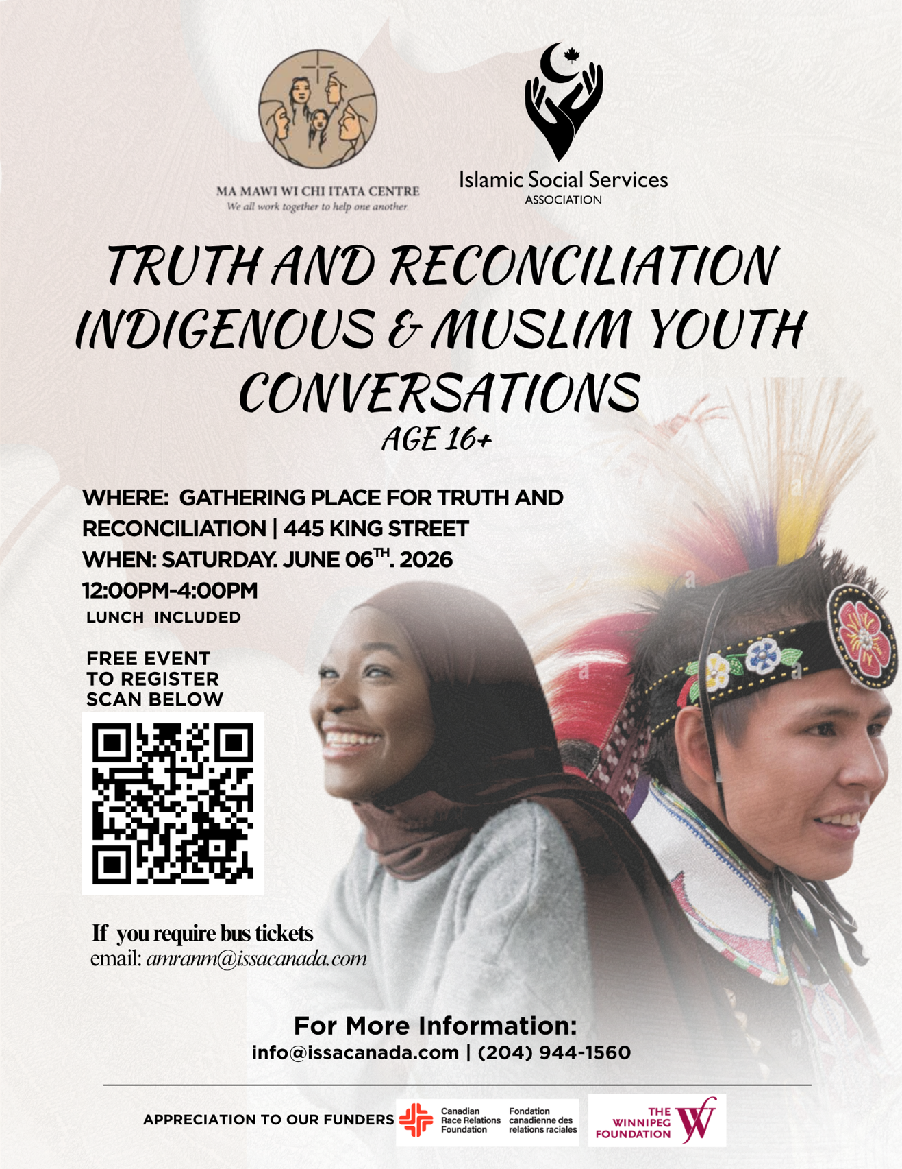
Program
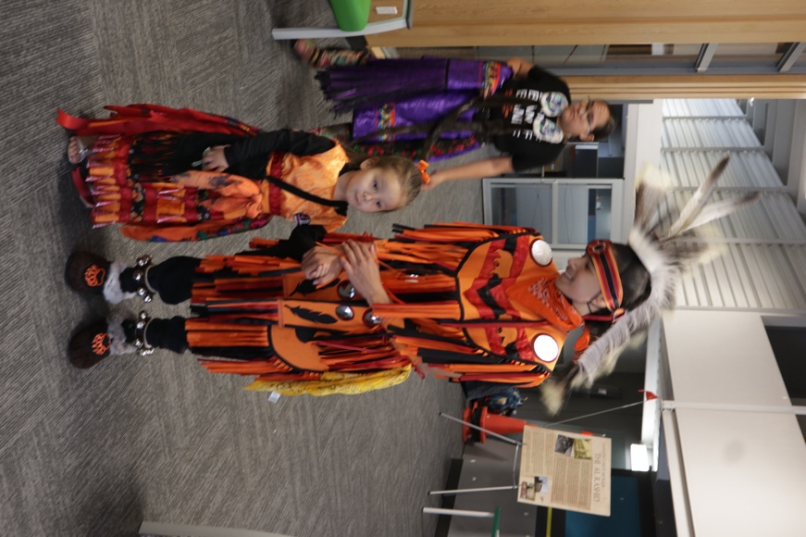
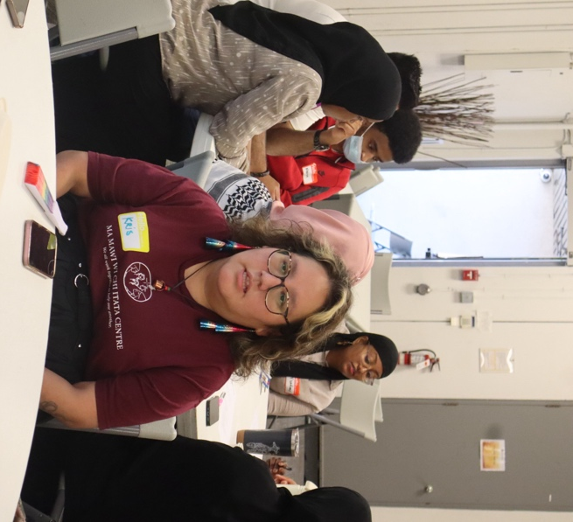
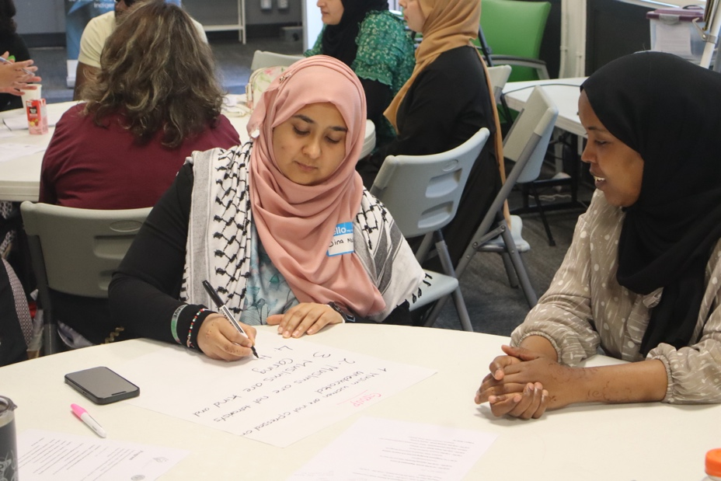
Photos
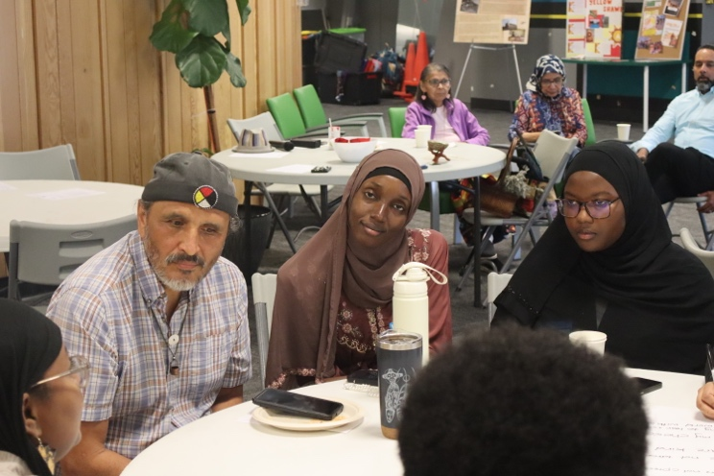
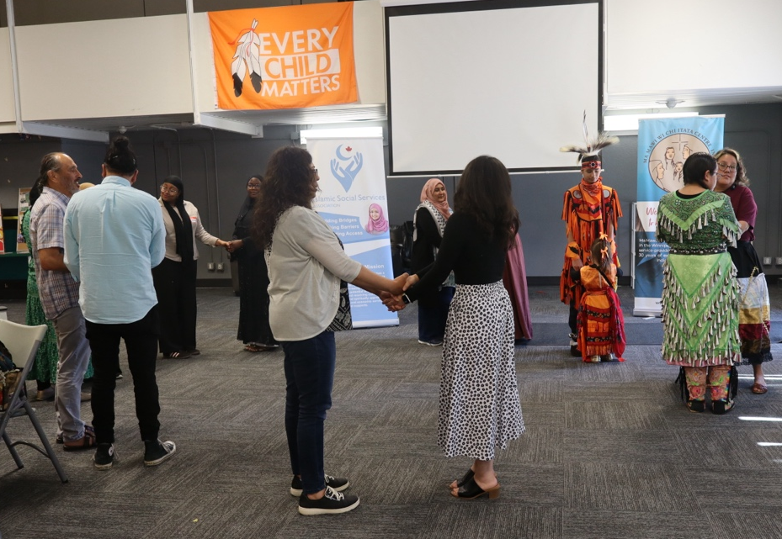
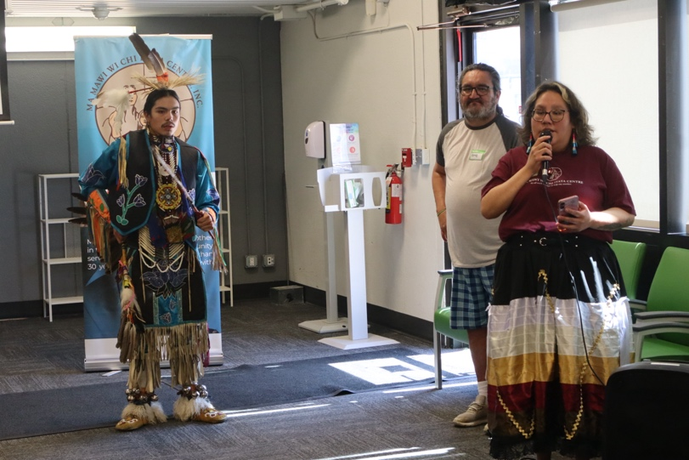
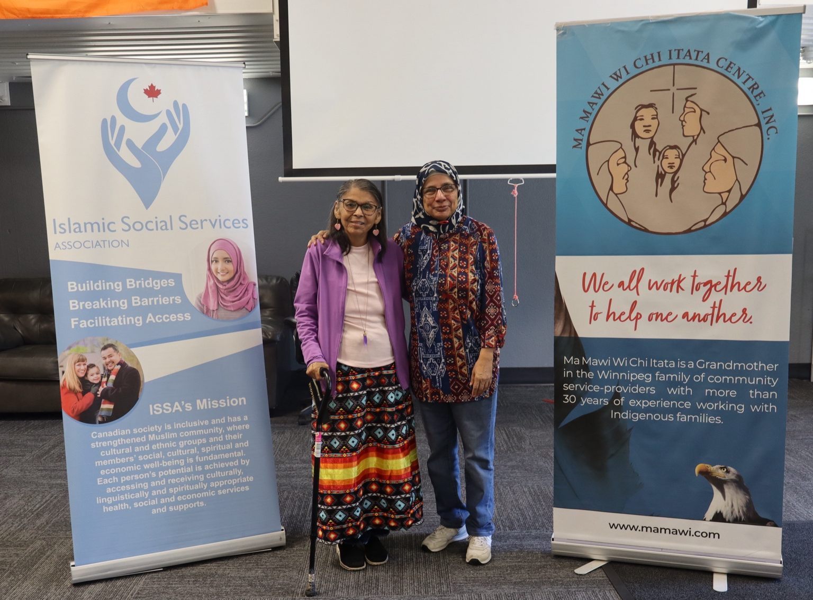
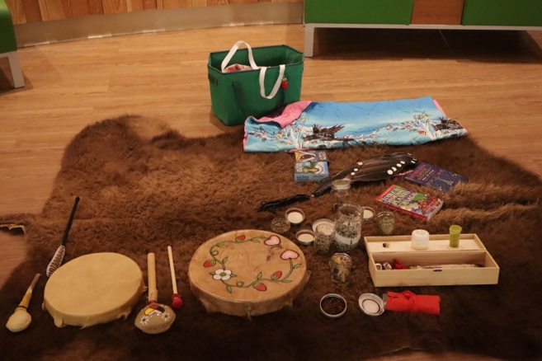

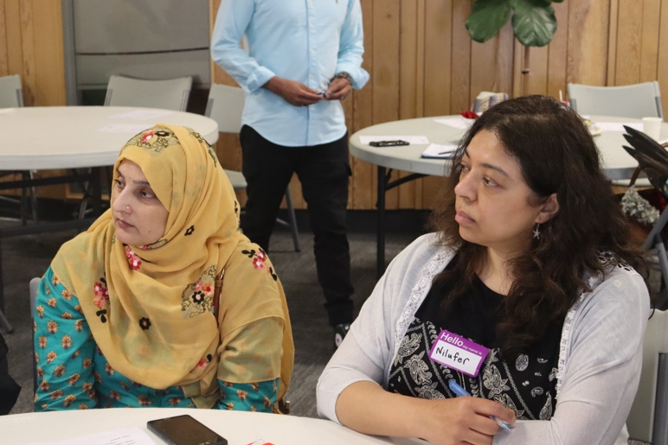
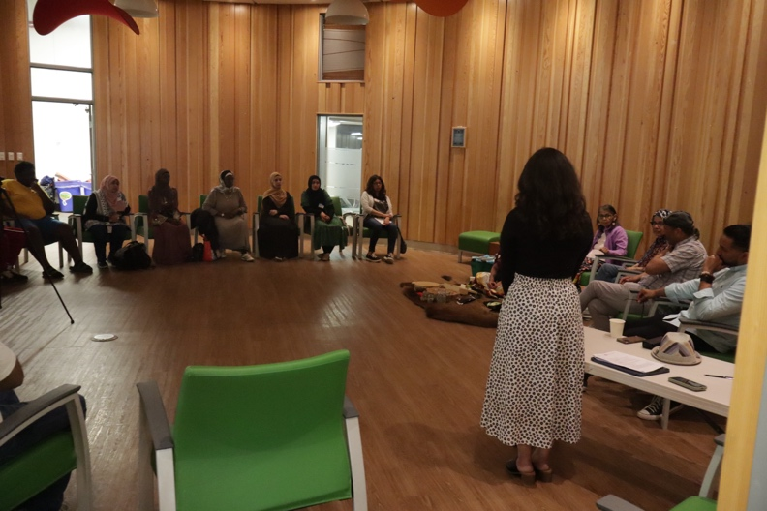

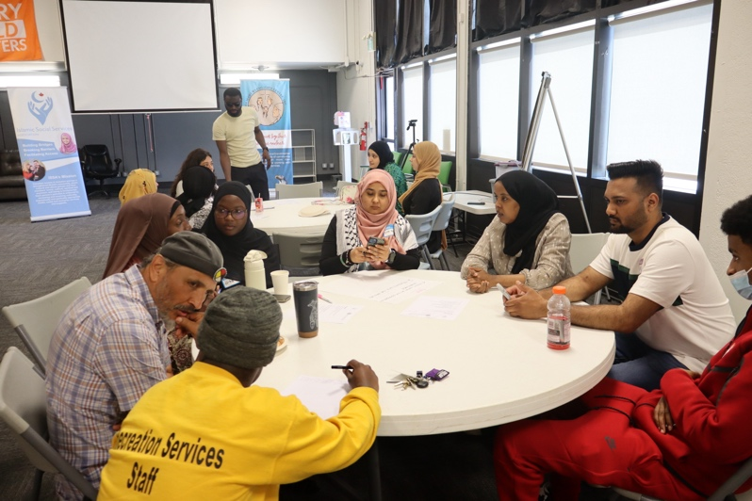
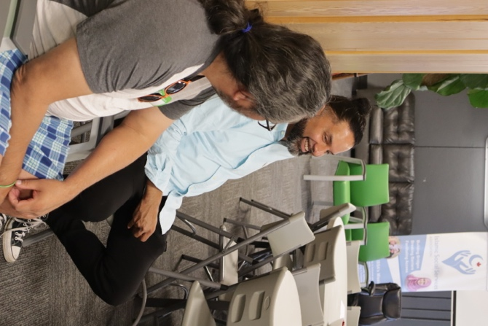
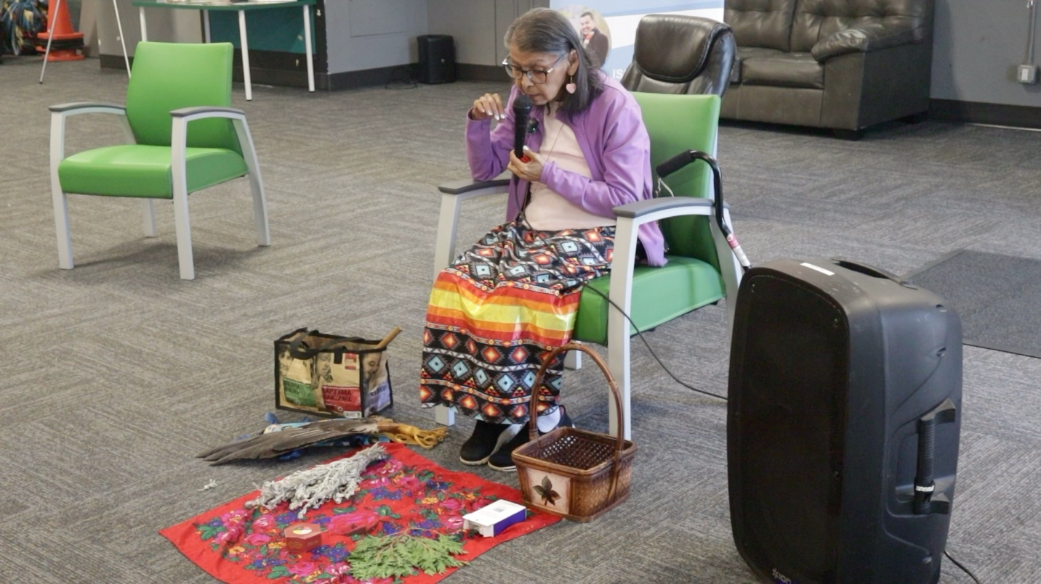
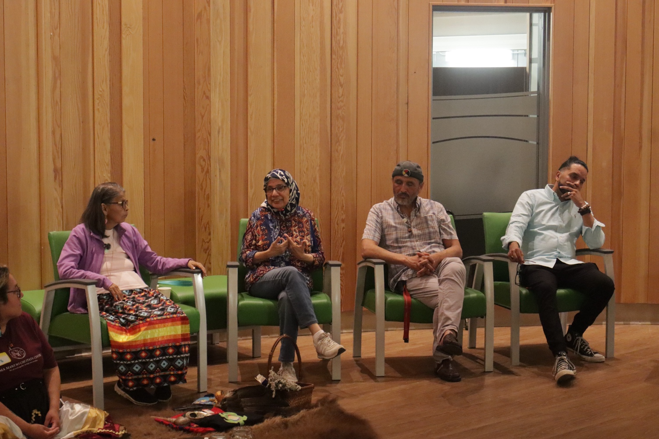
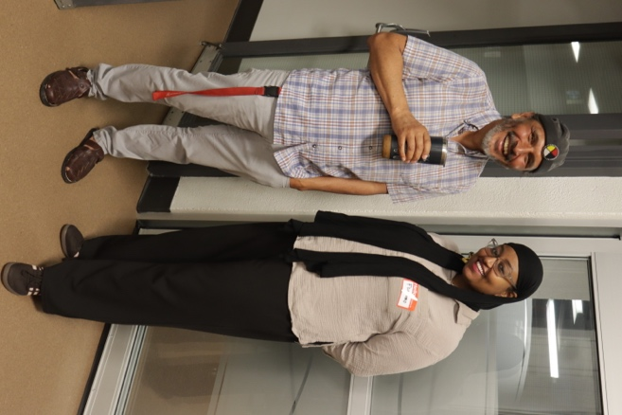
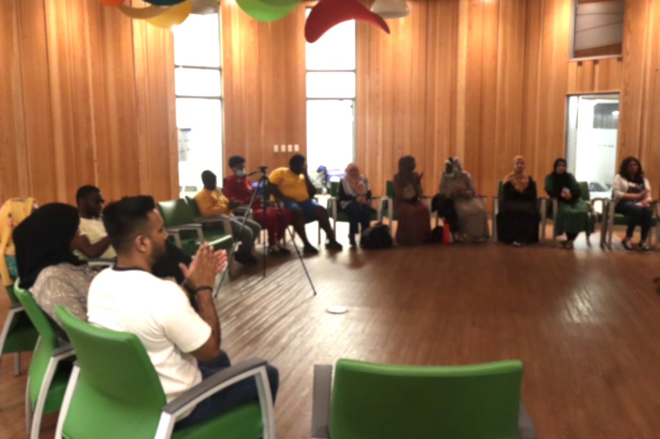

Videos:
Please copy and paste this link: TRC Videos
( https://issaservices-my.sharepoint.com/:f:/g/personal/amranm_issacanada_com/IgBtlhZ7cTi1SYbTEFG13zNiAdNsYlU71HuEwSQcZkb8K4I?e=CSmxRS) or
Scan the following QR Code

Password is: TRC

About ISSA

The Islamic Social Services Association (ISSA) is a community-based, non-profit charitable organization dedicated to building bridges, breaking barriers, and facilitating access for Muslim communities in Manitoba and across Canada. Guided by principles of justice, equality, and human dignity, ISSA works to address the mental health, social welfare, and family needs of diverse Muslim communities while advocating for culturally, linguistically, and spiritually appropriate services.
This workshop created a space where Muslim and Indigenous youth learned, reflected, and strengthened their understanding of Truth and Reconciliation while also developing the confidence to navigate systems that often overlook or misunderstand their experiences.

Contact Information
Islamic Social Services Association (ISSA)
1200-191 Lombard Ave
Winnipeg, MB
R3B 0X1
204-944-1560
Phone: 204-944-1560
Website: www.issacanada.com
General Inquiries
info@issacanada.com

