

Workshop Feedback Report
This workshop was designed to teach youth ages 16+ the art of storytelling and the impact of storytelling in healing.

Prepared By:
Amran Mahamed | Social Media and Engagement Coordinator
amranm@issacanada.com | + 1 (204) 944 1560 | issacanada.com
April 28th, Tuesday, 2026
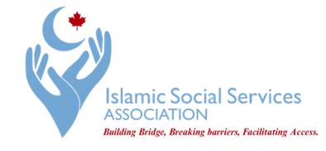

Introduction
The Islamic Social Services Association (ISSA) hosted the What’s Your Story? Youth Storytelling Workshop on Sunday, April 19, 2026, from 1:00 PM to 5:00 PM at Bill and Helen Norrie Library in Winnipeg. The workshop was designed for youth ages 16 and older as a space for storytelling, reflection, creativity, healing, and connection.
The main purpose of the workshop was to help youth understand that storytelling is not only about speaking in front of others or sharing something perfectly. It can also be a way to understand personal experiences, process emotions, build confidence, and connect with others. Many young people carry responsibilities, pressure, and emotions that are not always visible. This workshop gave participants a safe and respectful space to slow down, reflect, and express parts of themselves that they may not usually share.
The event was also planned with accessibility in mind. Refreshments were provided, and bus tickets were available for youth who needed transportation support. This mattered because removing practical barriers helps make the space more welcoming and allows more youth to take part without feeling excluded because of cost, transportation, or other challenges.
The workshop was not meant to feel like a formal presentation where participants only listened. It was meant to begin a process of youth engagement where participants could feel seen, heard, and supported through both conversation and creative expression.

Goals of the Workshop
The goals of the workshop were connected to each part of the day. The first goal was to create a comfortable space where youth could reflect on who they are, how they see themselves, and how others may see them. This helped participants move beyond surface-level introductions and begin thinking more deeply about identity, emotions, values, and personal experiences.
The second goal was to introduce storytelling as a tool for healing and connection. Through guided discussion, participants were encouraged to see that personal stories have value, even when they are unfinished, complicated, or difficult to explain. The workshop also showed that people can connect through listening, not only through speaking.
The third goal was to use creative expression as another form of storytelling. Since not every feeling can be explained through words, the art activity gave participants another way to express what they carry inside. This helped make the workshop more inclusive for participants who may feel more comfortable creating, drawing, or reflecting quietly before sharing.
The final goal was to build community. The workshop allowed participants to recognize that other people may carry similar emotions, hopes, pressures, and questions. This helped reduce isolation and encouraged connection between participants.

Program and Activities
The day began with a welcome, opening dua, and an introduction from ISSA staff. This opening helped set a calm and respectful tone for the workshop. Participants were given a sense of what the day would involve and why the workshop was being held. Starting this way was important because the activities required trust, reflection, and openness.
The first main session was led by Courtney Friesen. Courtney is the Director of Partnerships at Kahanee and brings a strong background in storytelling, connection, empathy, and advocacy. Her role in the workshop was important because her session helped participants begin reflecting through story before moving into deeper personal expression.
Courtney introduced participants to The Star and the Mountain, written by Somia Sadiq. The story follows a star and a mountain who care deeply for each other but exist in very different ways. The star is full of movement, light, and emotion, while the mountain is grounded, still, and responsible for protecting the people who depend on him. The story created a meaningful opening for participants to talk about relationships, responsibility, emotional distance, sacrifice, and the different ways people carry love and care.
This activity worked well because it did not force participants to immediately speak about themselves directly. Instead, they could first respond to the story, then connect it to their own experiences if they felt comfortable. This made the conversation feel more natural and less pressured. One participant later shared that they enjoyed the conversation about The Star and the Mountain, and another said the story became more powerful because everyone connected to it differently.
After the first session, the workshop included a prayer and break period. This gave participants time to pause, reset, and observe Dhuhr prayer together. Including prayer was important because it respected the needs of the participants and helped the day feel grounded, rather than rushed from one activity to the next.
The second session was led by Svetlana Pepin, a Winnipeg-based art therapist who works with children, youth, and adults through creative expression. Her session was called Galaxy Within. This activity focused on helping participants reflect on the difference between how the world sees them and what they carry inside.
The activity began with a mingling exercise and small group discussion. Participants used character strength cards to reflect on qualities they already felt strong in and qualities they may want to develop. Svetlana then introduced a quote attributed to Imam Ali: “You presume you are a small entity, but within you is enfolded the entire Universe.” This quote became the foundation for the self-portrait activity.
Participants created a half-face portrait. One side represented how the world sees them, such as school, work, hobbies, responsibilities, and daily life. The other side represented their “inner universe,” including dreams, values, talents, spiritual qualities, emotions, and parts of themselves that people may not always see. They used symbols, stars, colours, and creative details to show their inner world.
The activity was effective because it gave participants a way to express things that may be hard to say out loud. One participant said the Galaxy Within activity helped them think about how people see them compared to what they actually feel inside. Another participant said the art activity stood out because it helped them express things they normally keep to themselves.

Participant Feedback
The feedback showed that participants experienced the workshop as meaningful, comfortable, and personal. Several participants said the workshop met or went beyond their expectations because it allowed them to meet new people, reflect, and learn about others’ stories. One participant said the workshop helped them interact with new people and learn how others think about themselves. Another said they enjoyed the conversation, the art session, and the overall atmosphere.
A stronger theme in the feedback was that participants did not feel like they were just being spoken to. One participant said the workshop felt interactive and respectful, and that being able to reflect and share made it more meaningful. Another participant said the space felt comfortable and welcoming, which made it easier to participate honestly.
Participants also identified clear learning outcomes. They shared that they learned everyone has their own story, even if they do not always talk about it. They also learned that art can help express emotions that are hard to explain, and that listening to other people’s experiences helps build understanding.
The feedback also showed which parts of the workshop had the strongest impact. Some participants connected most with Courtney’s storytelling session, especially the discussion around The Star and the Mountain. Others connected most with Svetlana’s art activity, especially because it allowed them to reflect visually and personally. One participant said the card activity in Svetlana’s session felt relatable, while another directly identified the art and craft session as their favourite part.

Facilitator Feedback
The facilitator feedback also helped show what worked and what should be improved. Svetlana shared that participants appeared engaged throughout the day and seemed to make meaningful connections. She also noticed that participants gained insight into themselves and was especially impressed by the hopes and career goals they shared during the workshop.
Svetlana also pointed out that the support offered by ISSA, including food and bus tickets, helped make the workshop more inclusive and welcoming. This was important feedback because it confirmed that accessibility planning was not just an extra detail, but part of what helped participants feel comfortable attending and staying engaged.
One of Svetlana’s main recommendations was that workshops like this should be approached more intentionally as an ongoing process. This is an important point because the workshop created trust and reflection, but one afternoon is not enough to fully build on that. Her feedback connects directly with what participants also said: they wanted more time, clearer timing, and follow-up sessions.

What Can Be Improved
The workshop was successful, but the feedback shows that future sessions can be stronger with a few clear changes.
First, the workshop needs more time for the expressive art portion. Several participants specifically asked for more time with Svetlana’s session or said the event felt rushed. Since the art activity brought out strong reflection, future workshops should either make the session longer or reduce the number of activities so participants have enough time to create, reflect, and share.
Second, the start time and event communication should be clearer. Some feedback mentioned that the start time could have been clearer. For future events, this can be improved through reminder emails, social media reminders, and a clear message the day before the workshop with the time, location, parking information, bus ticket information, and what participants should expect.
Third, the workshop should not stay as a one-time event. Both participant and facilitator feedback pointed toward the need for follow-up. One participant said it would be better if there were follow-up sessions so people could continue building connections instead of having only one day. This shows that participants were not just attending passively. They wanted the work to continue.
Fourth, future workshops should include a stronger closing reflection. The closing did include feedback and acknowledgements, but the next version could give participants more time to share what they are taking with them, what support they still need, and what topics they want ISSA to focus on next.

Acknowledgements
ISSA would like to thank Courtney Friesen and Svetlana Pepin for facilitating the workshop with care, patience, and thoughtfulness. Courtney’s storytelling session helped open the room and gave participants a gentle way to reflect on meaning, relationships, and personal experience. Svetlana’s expressive art session gave participants a creative way to explore identity, inner strengths, and emotions that are not always visible.
Special appreciation goes to Samda Suleiman for her support, coordination, and presence throughout the workshop. Her work helped the event run smoothly and helped create a welcoming environment for participants.
Thank you also to volunteer Saif Ali for supporting the setup, logistics, and participant needs during the event. These behind-the-scenes roles are important because they help the workshop feel organized, calm, and supportive.
Most importantly, thank you to the participants. Their openness, honesty, and willingness to engage are what made the workshop meaningful. The success of the day came from their reflections, their stories, and the trust they brought into the space.

Next Steps
The strongest outcome of What’s Your Story? was that participants felt safe enough to reflect, create, and connect with others. The feedback shows that youth valued the space and wanted more opportunities like it.
The next step should be to build this workshop into an ongoing youth series rather than leaving it as a single event. Future sessions could include storytelling circles, expressive arts activities, reflection groups, and mentorship-based conversations. These sessions should give youth enough time to build trust, return to earlier reflections, and continue developing confidence in sharing their stories.
The workshop showed that youth do not only need information. They need spaces where they can be heard, where their emotions are taken seriously, and where they can connect with others in a safe and creative way. What’s Your Story? was a strong beginning, and the feedback shows that it is worth continuing.

Flyer
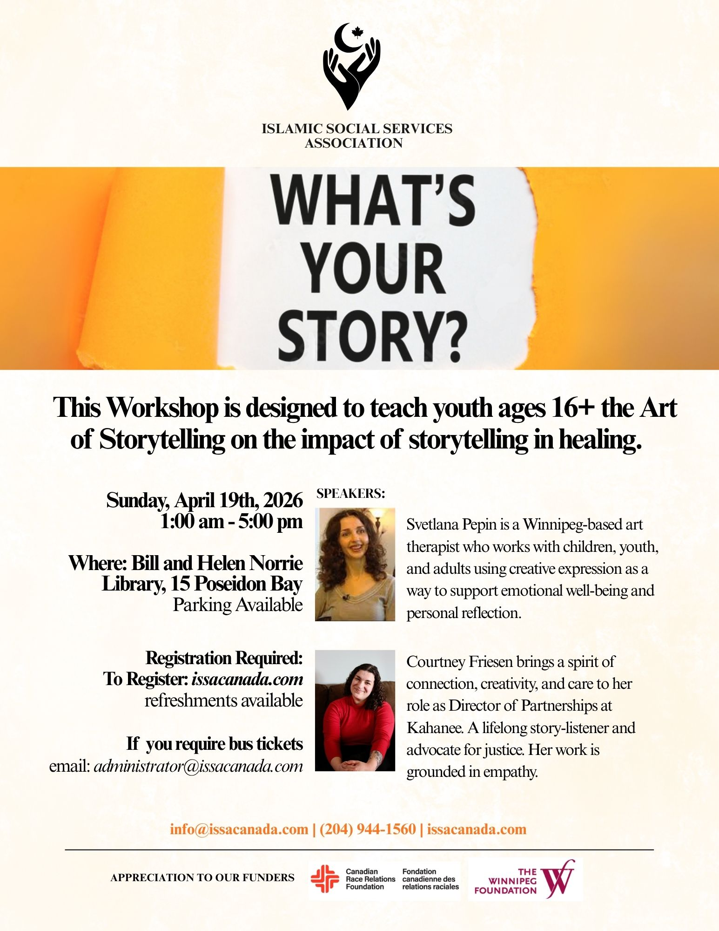

Program
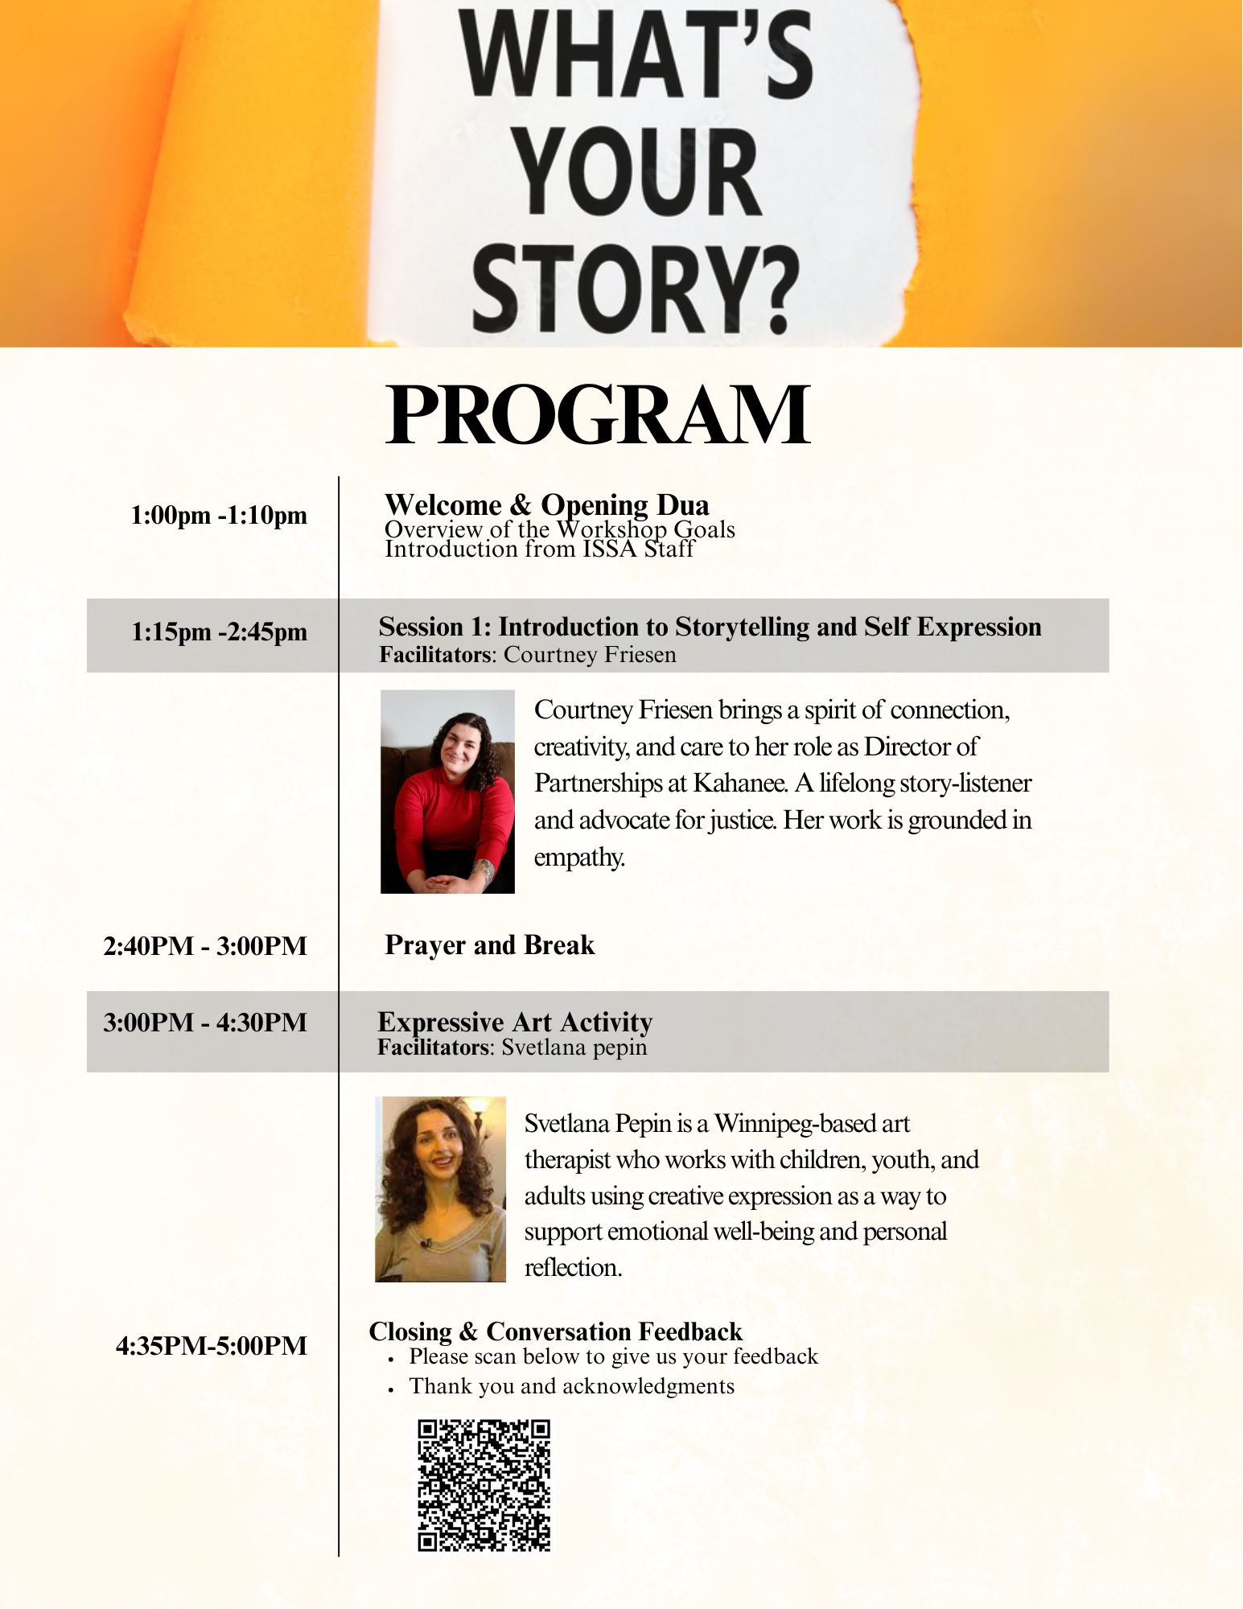

Activity 1

Activity 2:

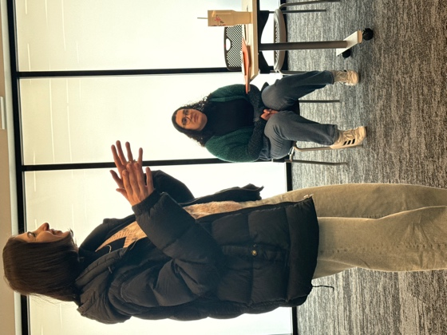
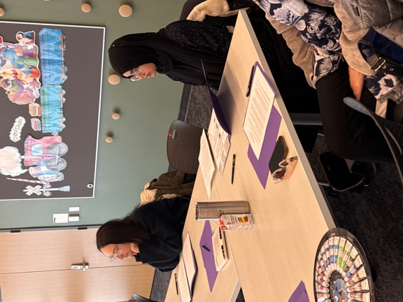
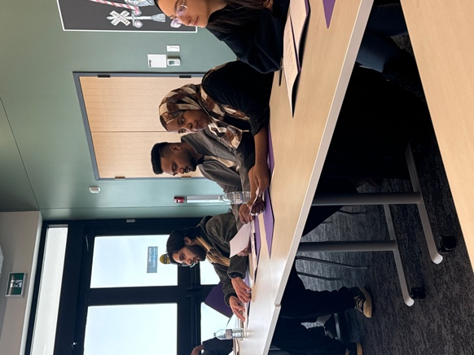
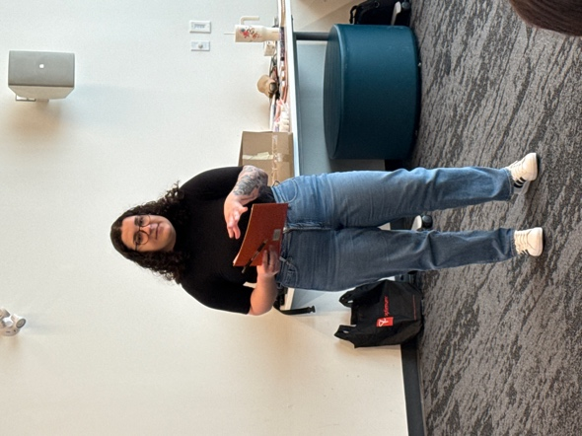
Photos:
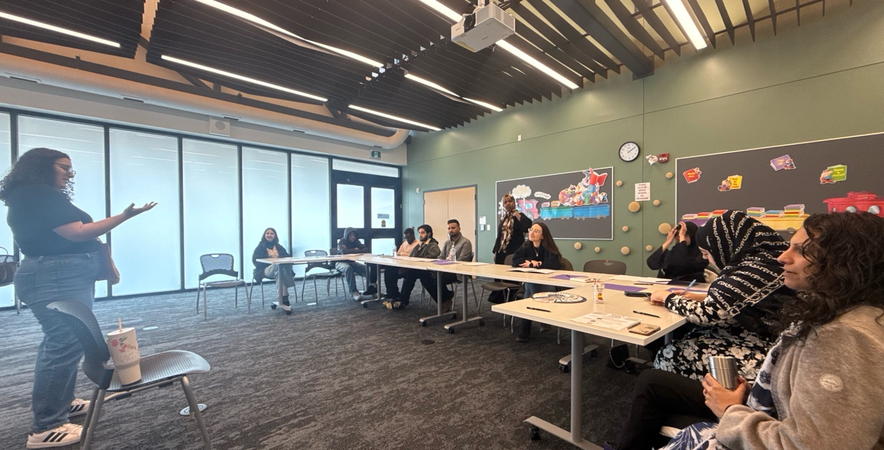
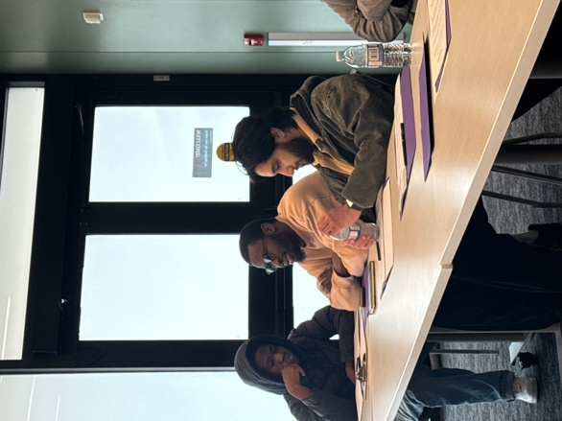
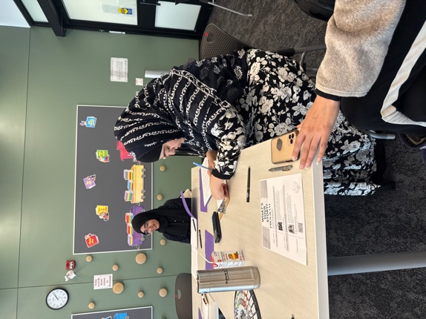
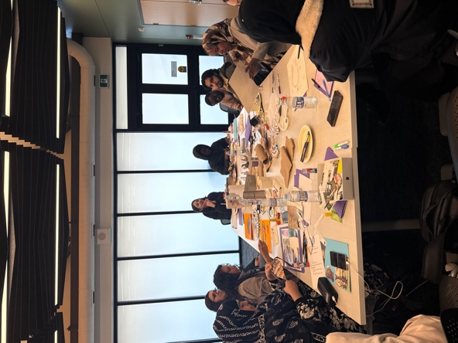
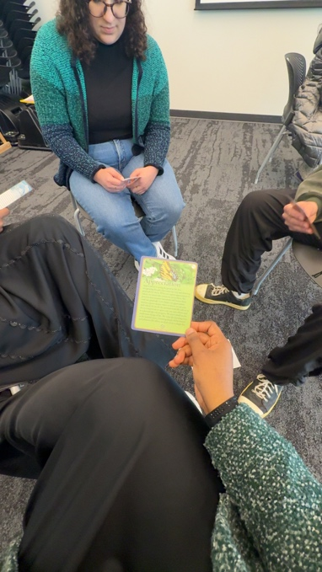
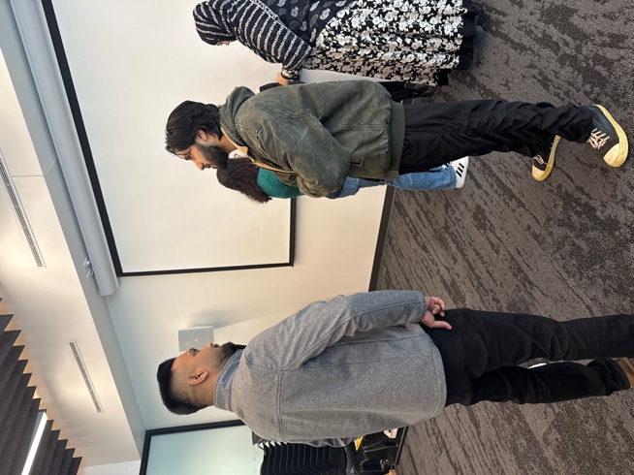
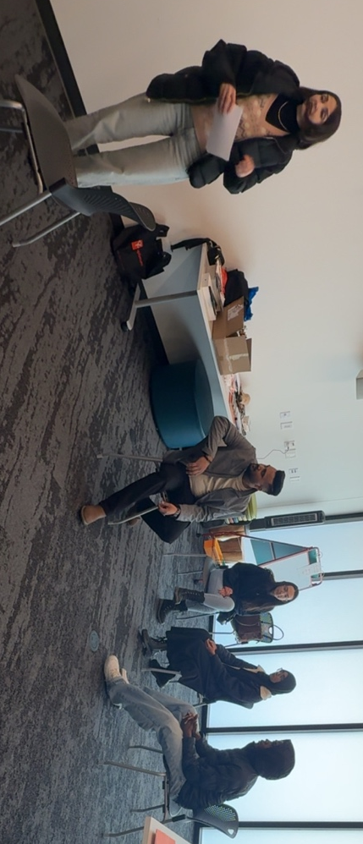
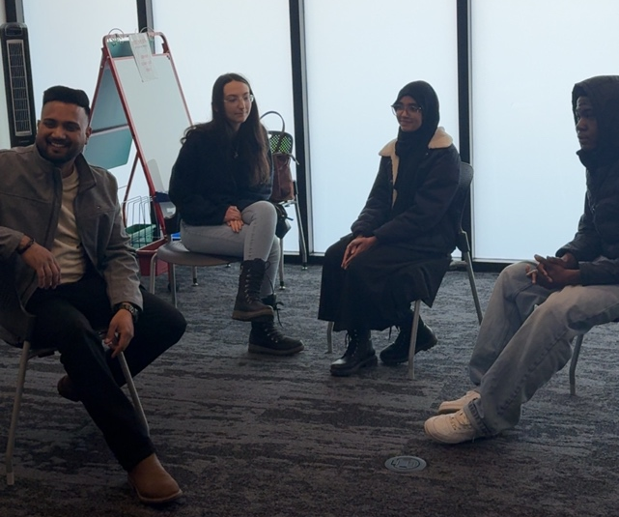
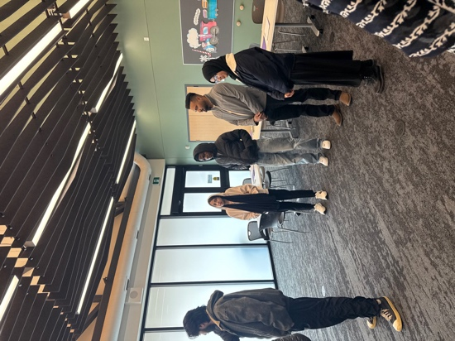
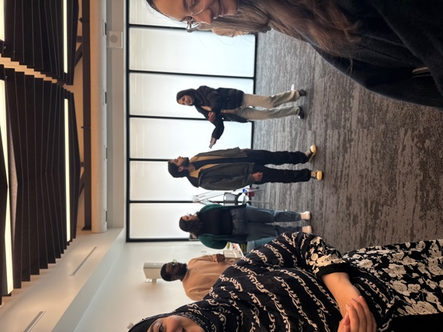
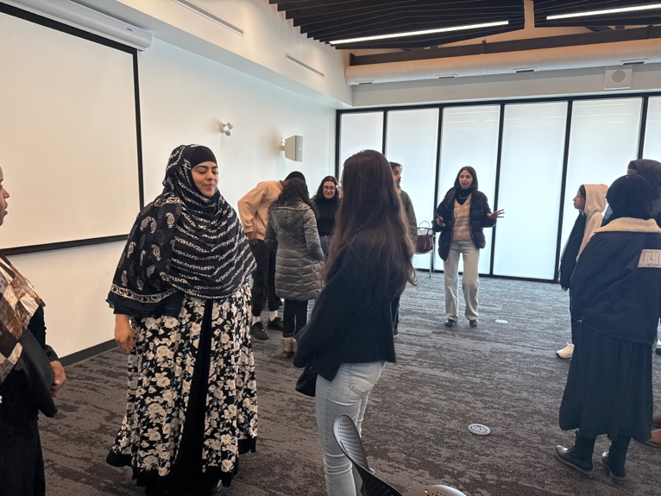

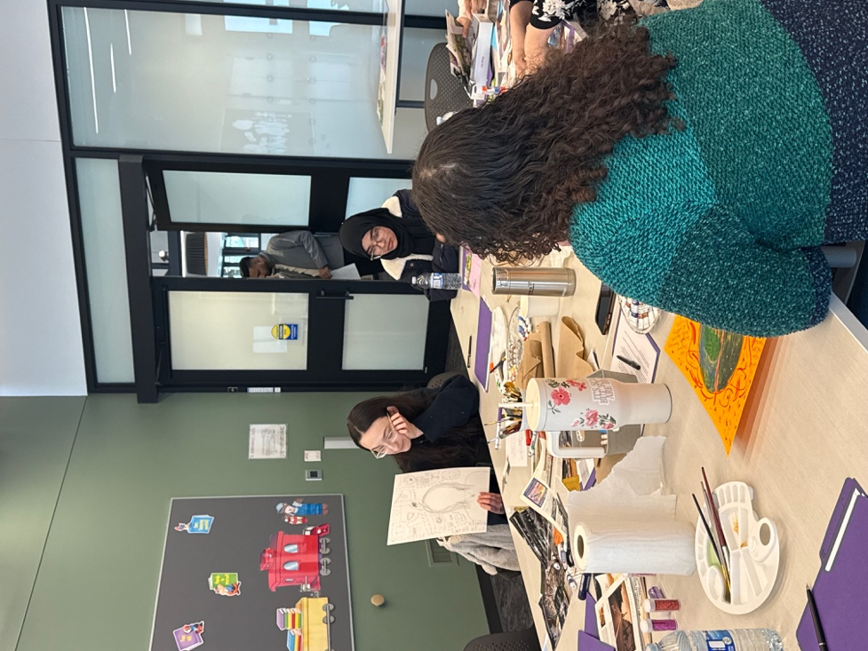
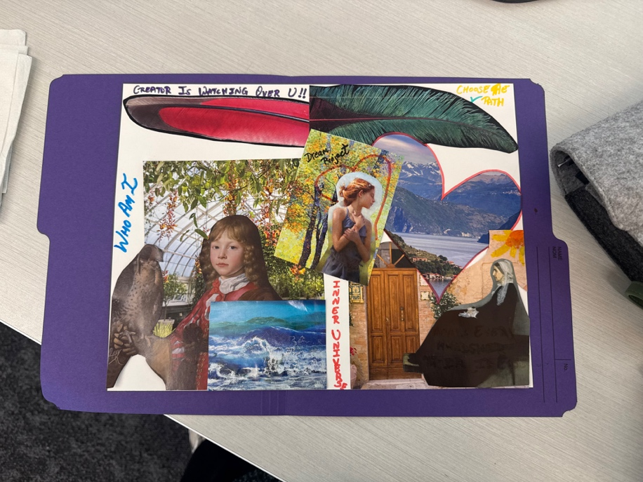
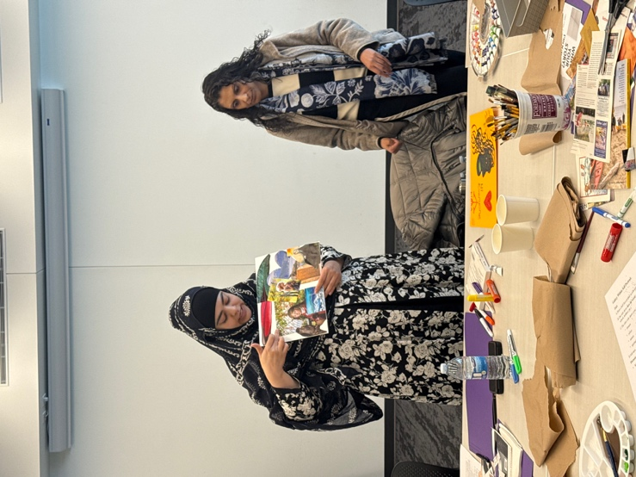

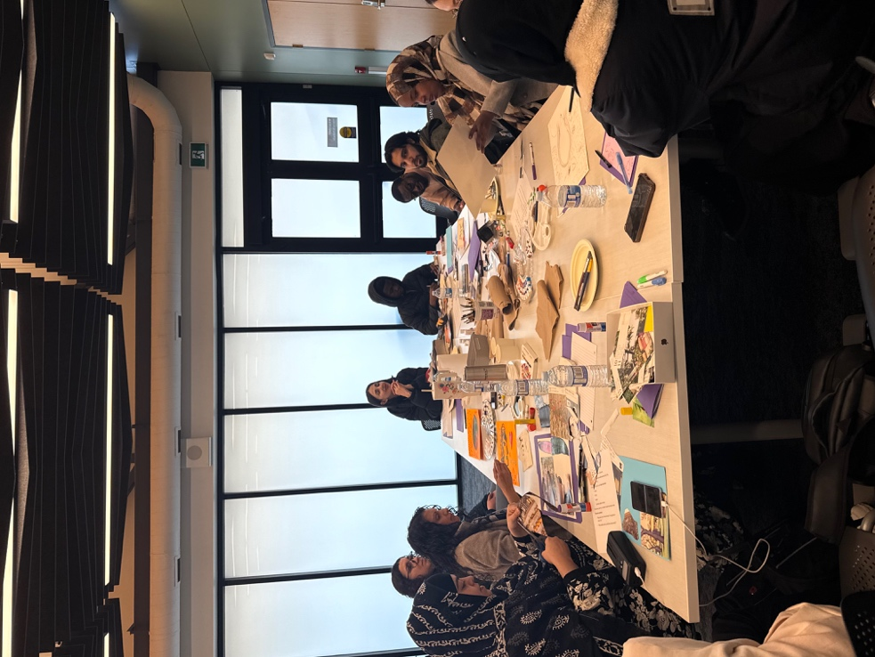
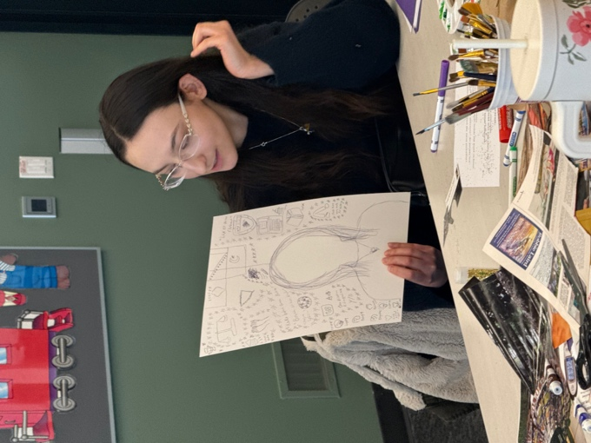
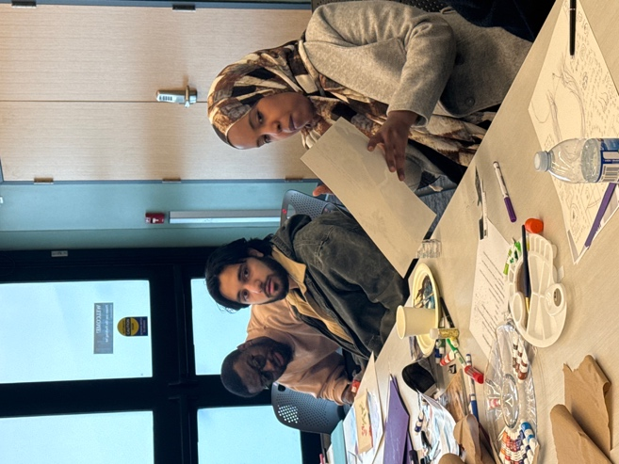
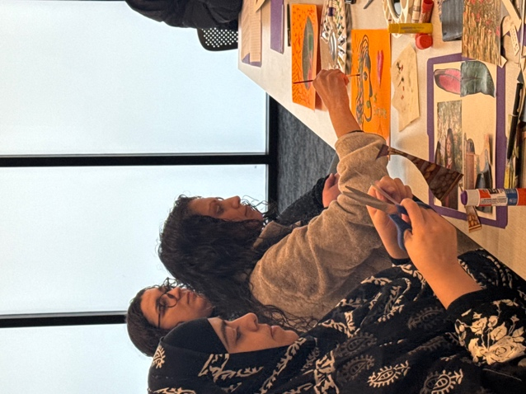
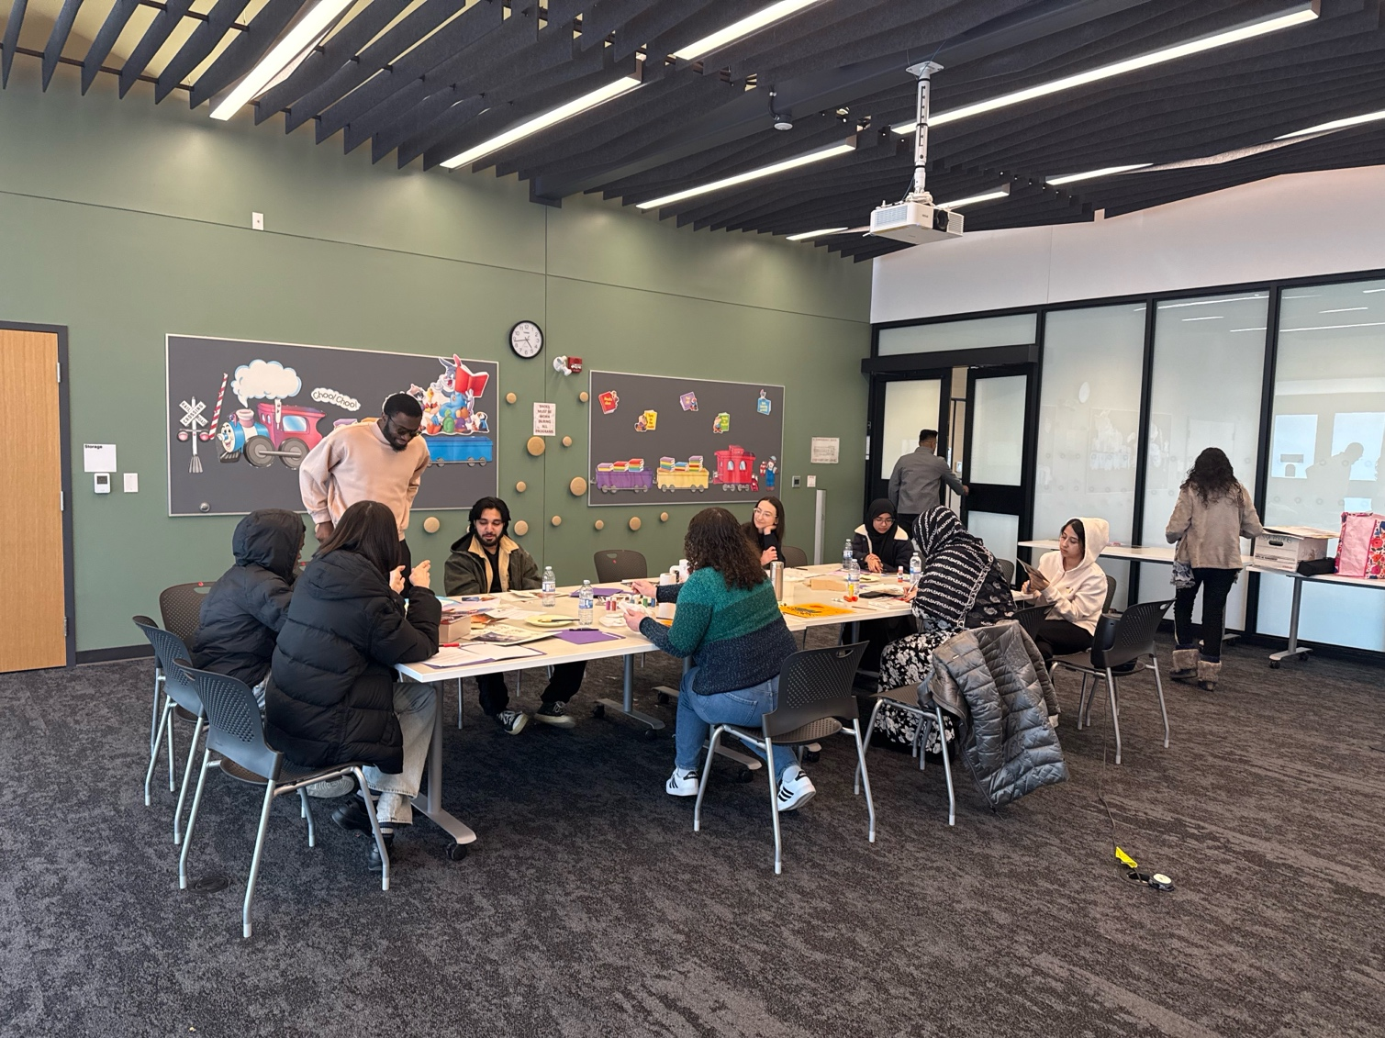

About ISSA

The Islamic Social Services Association (ISSA) is a community-based, non-profit charitable organization dedicated to building bridges, breaking barriers, and facilitating access for Muslim communities in Manitoba and across Canada. Guided by principles of justice, equality, and human dignity, ISSA works to address the mental health, social welfare, and family needs of diverse Muslim communities while advocating for culturally, linguistically, and spiritually appropriate services. This youth workshop reflects that mission: creating a space where Muslim youth can learn, reflect, and strengthen their understanding of identity and storytelling, while also developing the dialogue to navigate systems that often overlook or misunderstand their experiences

Contact Information
Islamic Social Services Association (ISSA)
1200-191 Lombard Ave
Winnipeg, MB
R3B 0X1
204-944-1560
Phone: 204-944-1560
Website: www.issacanada.com
General Inquiries (Counselling, Programs, Workshops, Events, Volunteering, Speaker Request, Marriage Commissioner Request……etc)
info@issacanada.com

